Using Canvas for Student Learning Outcomes (SLOs)
Using Canvas to collect SLO data has benefits for both the instructor and the institution. This will streamline and improve the process that instructors use to collect SLO data and the student submissions become the artifacts for the SLO. Data collected at the institutional level can then be used to analyze SLOs as they relate to student demographics.
In order to properly collect SLO data at the account level the following steps must be taken:
- The instructor must be evaluating something contained in a graded Canvas Assignment, Discussion or Quiz. It can be part of the regular class or set up specifically to collect the data (It would be best to have students submit their work into canvas but is not essential)
- The instructor must provide the SLOs to the Instructional Tech to be entered into Canvas at the account level.
- The instructor will need to use an existing assignment rubric or create a rubric specifically for the outcome being evaluated and attach it to the assignment.
- The instructor must use the rubric to record the assessment scores for each student.
These instructions assume that you are familiar with Canvas and the basics of assignment setup, gradebook and SpeedGrader. If you need information about setting up an online Canvas assignment please contact your Instructional Tech. (Reno-Giovannetti@redwoods.edu – 476-4568)
After the SLOs have been added to Canvas by the Instructional Tech the instructor will need to complete the following steps:
- Import the outcomes from the account level into your Canvas course
- Attach a rubric to an assignment and Import the outcome into the rubric.
- Use SpeedGrader and the rubric to select an assessment score for each student.
- Access the Outcome data and review the report or download the data.
STEP 1: Import the outcomes from the account level into your Canvas course.
Click Outcomes and then Find.
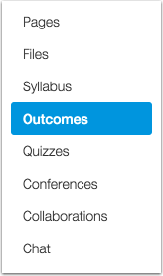

Click Account Standards then College of the Redwoods then, your division, course and finally the outcome you want to use.
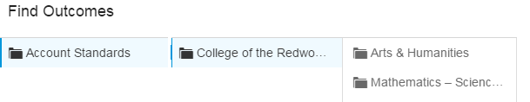
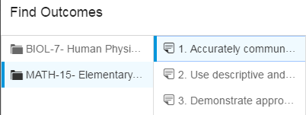
When you have located an outcome, click the name of the outcome you want to import and then click the Import button
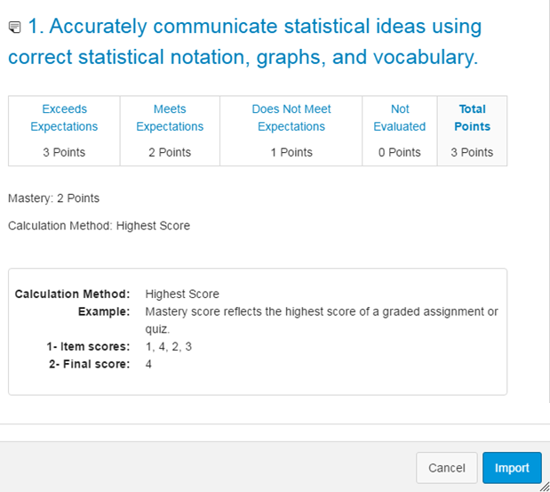

See: Find Account Outcomes for more information

STEP 2: Attach a rubric to an assignment and Import the outcome into the rubric
Open the assignment that you will be evaluating. You will need to edit the existing rubric or add a rubric to the assignment so that you can attach the outcome to the rubric. All Quizzes, Discussions and Assignments can have rubrics attached.
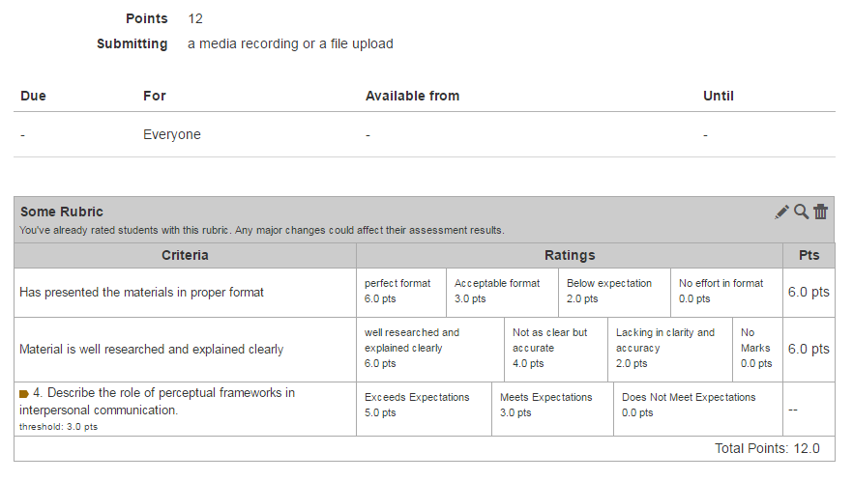
Then select find an outcome
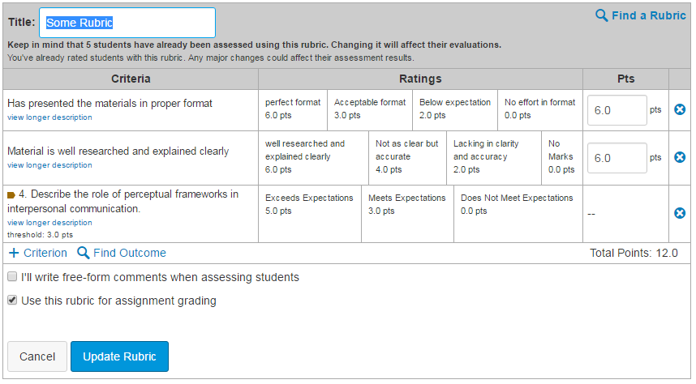

Select the outcome you just imported. IMPORTANT you must uncheck the Use this criterion for scoring checkbox or the 3 points will be added to total for the rubric. Click import at the bottom and then Update Rubric to complete the process. Note – Do not use Free-form Comments for outcomes (make sure this box is unchecked)

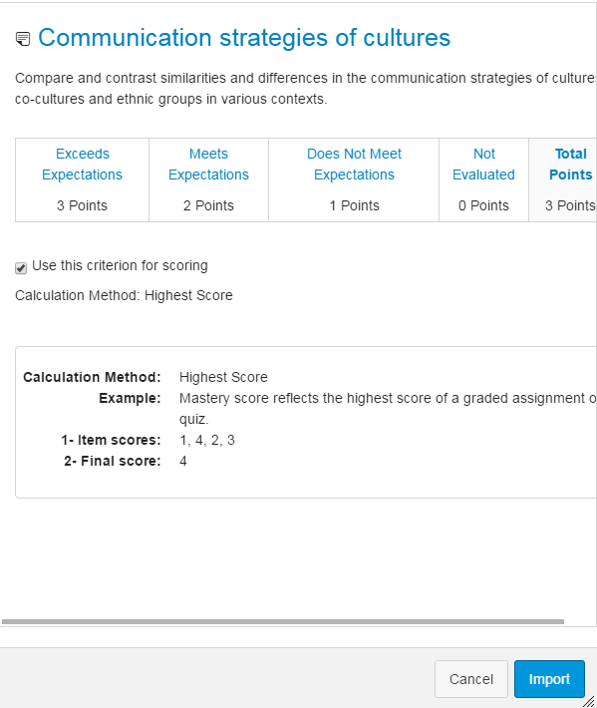

See Add Outcome to a rubric for more information

Note that the Outcome will show with an Icon indicating it is for an Outcome. Also note that the score will not impact the grade for the rubric.
STEP 3: Use SpeedGrader and the rubric to select an assessment score for each student..
During the grading process you will use the SpeedGrader and the rubric to select an assessment score for the individual students. Simply view the rubric and click on the assessment score you want to use. Remember if the student did not participate you should select Not Evaluated 0 (all student must have a an assessment score even if they did not submit work)
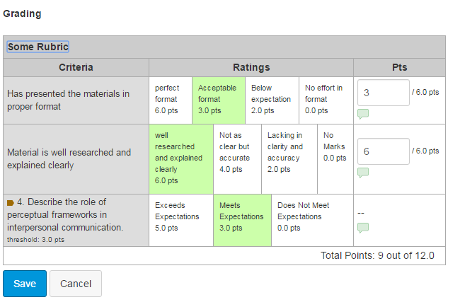

STEP 4: Access the Outcome data and review the report or download the data.
To view your results you will need to enable an option called The Mastery Gradebook. We will be using this option to view and download your results so you can add them to your SLO Report. Click on Settings, then Feature Options and click the checkmark for Leaning Mastery Gradebook
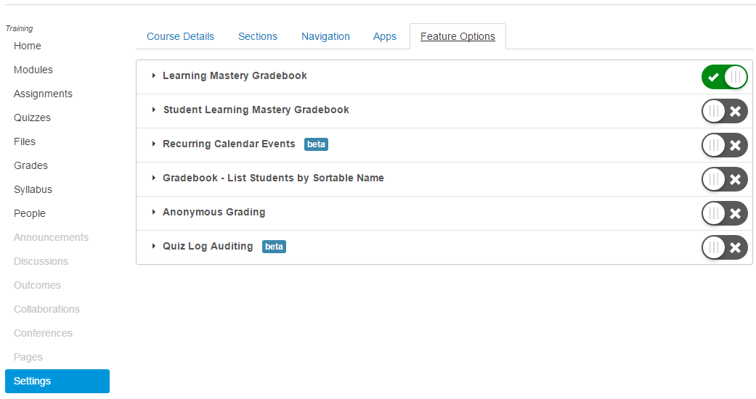
Once you have enabled this option you will have a new button in your gradebook Learning Mastery

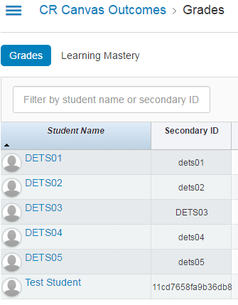
The Learning Mastery gradebook will list your outcome results.
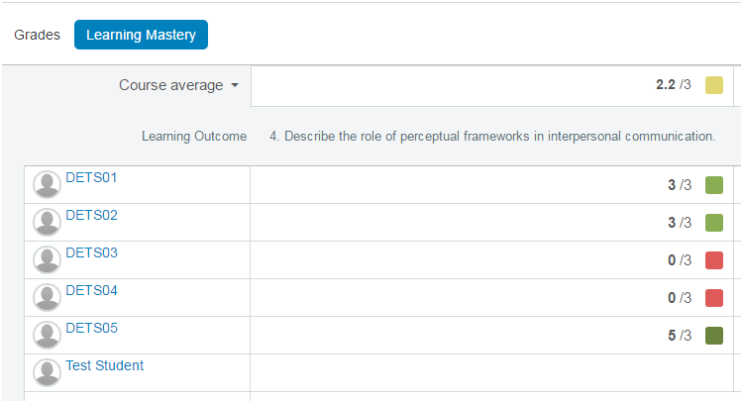
In addition you can export the date to a spreadsheet for analysis.
