

Child Development Center

STAFF HANDBOOK

2017-18

Center: 476-4337
Director: 476-4537
FAX 476-4414


TABLE OF CONTENTS

INTRODUCTION 4
Mission 4
History 4
Licensing Information 4
Children and Families Served 5
Hours and Holidays 5
CHILD DEVELOPMENT CENTER GUIDING PRINCIPLES 5
Program Philosophy 5
Play-Based Curriculum 5
Program Goals for Children 6
Program Goals for Families 7
Building Bonds With Families 7
Environment 8
Family Responsibility 8
Guidance Policy 10
Staffing Protocol and Confidentiality 12
Supervision and Accident Prevention 14
Child Accident and Incident Issues 14
MANDATED REPORTING RESPONSIBILITIES 15
Suspected Child Abuse Reporting Error! Bookmark not defined.
Notification of Communicable Illness 17
Health Department Reporting 17
Community Care Licensing Reporting 17
HEALTH PROCEDURES 18
Daily Health Screening 18
Re-admission to School 19
Hand Washing 19
Sanitation Procedures 20
Latex/Vinyl Gloves 22
Medication Policy 22
Rest Needs & Naps 23
Safety and Licensing 23
Emergency Medical Care & Procedures 23
Nutrition Program 24
EMPLOYEE HEALTH AND SAFETY 25
Safety Practices 25
Storage 25
Housekeeping 26
Lifting and Carrying 26
EMPLOYMENT INFORMATION 26
Employee Requirements 27
Staff Orientation 27
Staff Development 27
Designation of Authority 28
Work Schedules and Assignments 29
Time Sheets 29
Paychecks 29
STANDARDS OF CONDUCT 30
Work time 30
Work Performance 30
Attendance, Permanent Employees 30
Attendance, Student Employees and Lab Students 30
Attitude 31
Confidentiality 31
Expectations of Professionalism…………………………………………………………..…31
Parking…………………………………………………………………………………………..…32
Smoking……………………………………………………………………………………………32
Telephone…………………………………………………………………………………………33
Resignation 32
Complaints/Concerns 33
Nondiscrimination/Equal Opportunity 33
Sexual Harassment 33
Uniform Complaint Procedure…………………………………………………………………34
Extemded Curriculum Statement……………………………………………………………..35
NAEYC Program Standards and Code of Ethical Conduct 38

INTRODUCTION

Mission

The College of the Redwoods Child Development Center (CDC) embraces and supports the individuality of each child in an authentic, emerging learning environment while modeling best practices and providing a high quality laboratory setting for early childhood education students.

The CDC seeks to implement the most current theories and practices in the early childhood education field. The CDC permanent teaching staff, in collaboration with the faculty of the Early Childhood Education program, designs curriculum and procedures. This ensures continuity for ECE students, who are able to observe and participate in a program that implements the theories and practices they are learning about in class.

The CDC permanent staff appreciates ECE students, substitutes, student employees, and volunteers for their involvement and assistance in the CDC program. Educating and caring for children involves a variety of tasks including individual and small group projects, as well as washing dishes, doing laundry and other environmental maintenance routines. ECE students, Federal Work Study students and volunteers participate in many aspects of CDC operations.

History
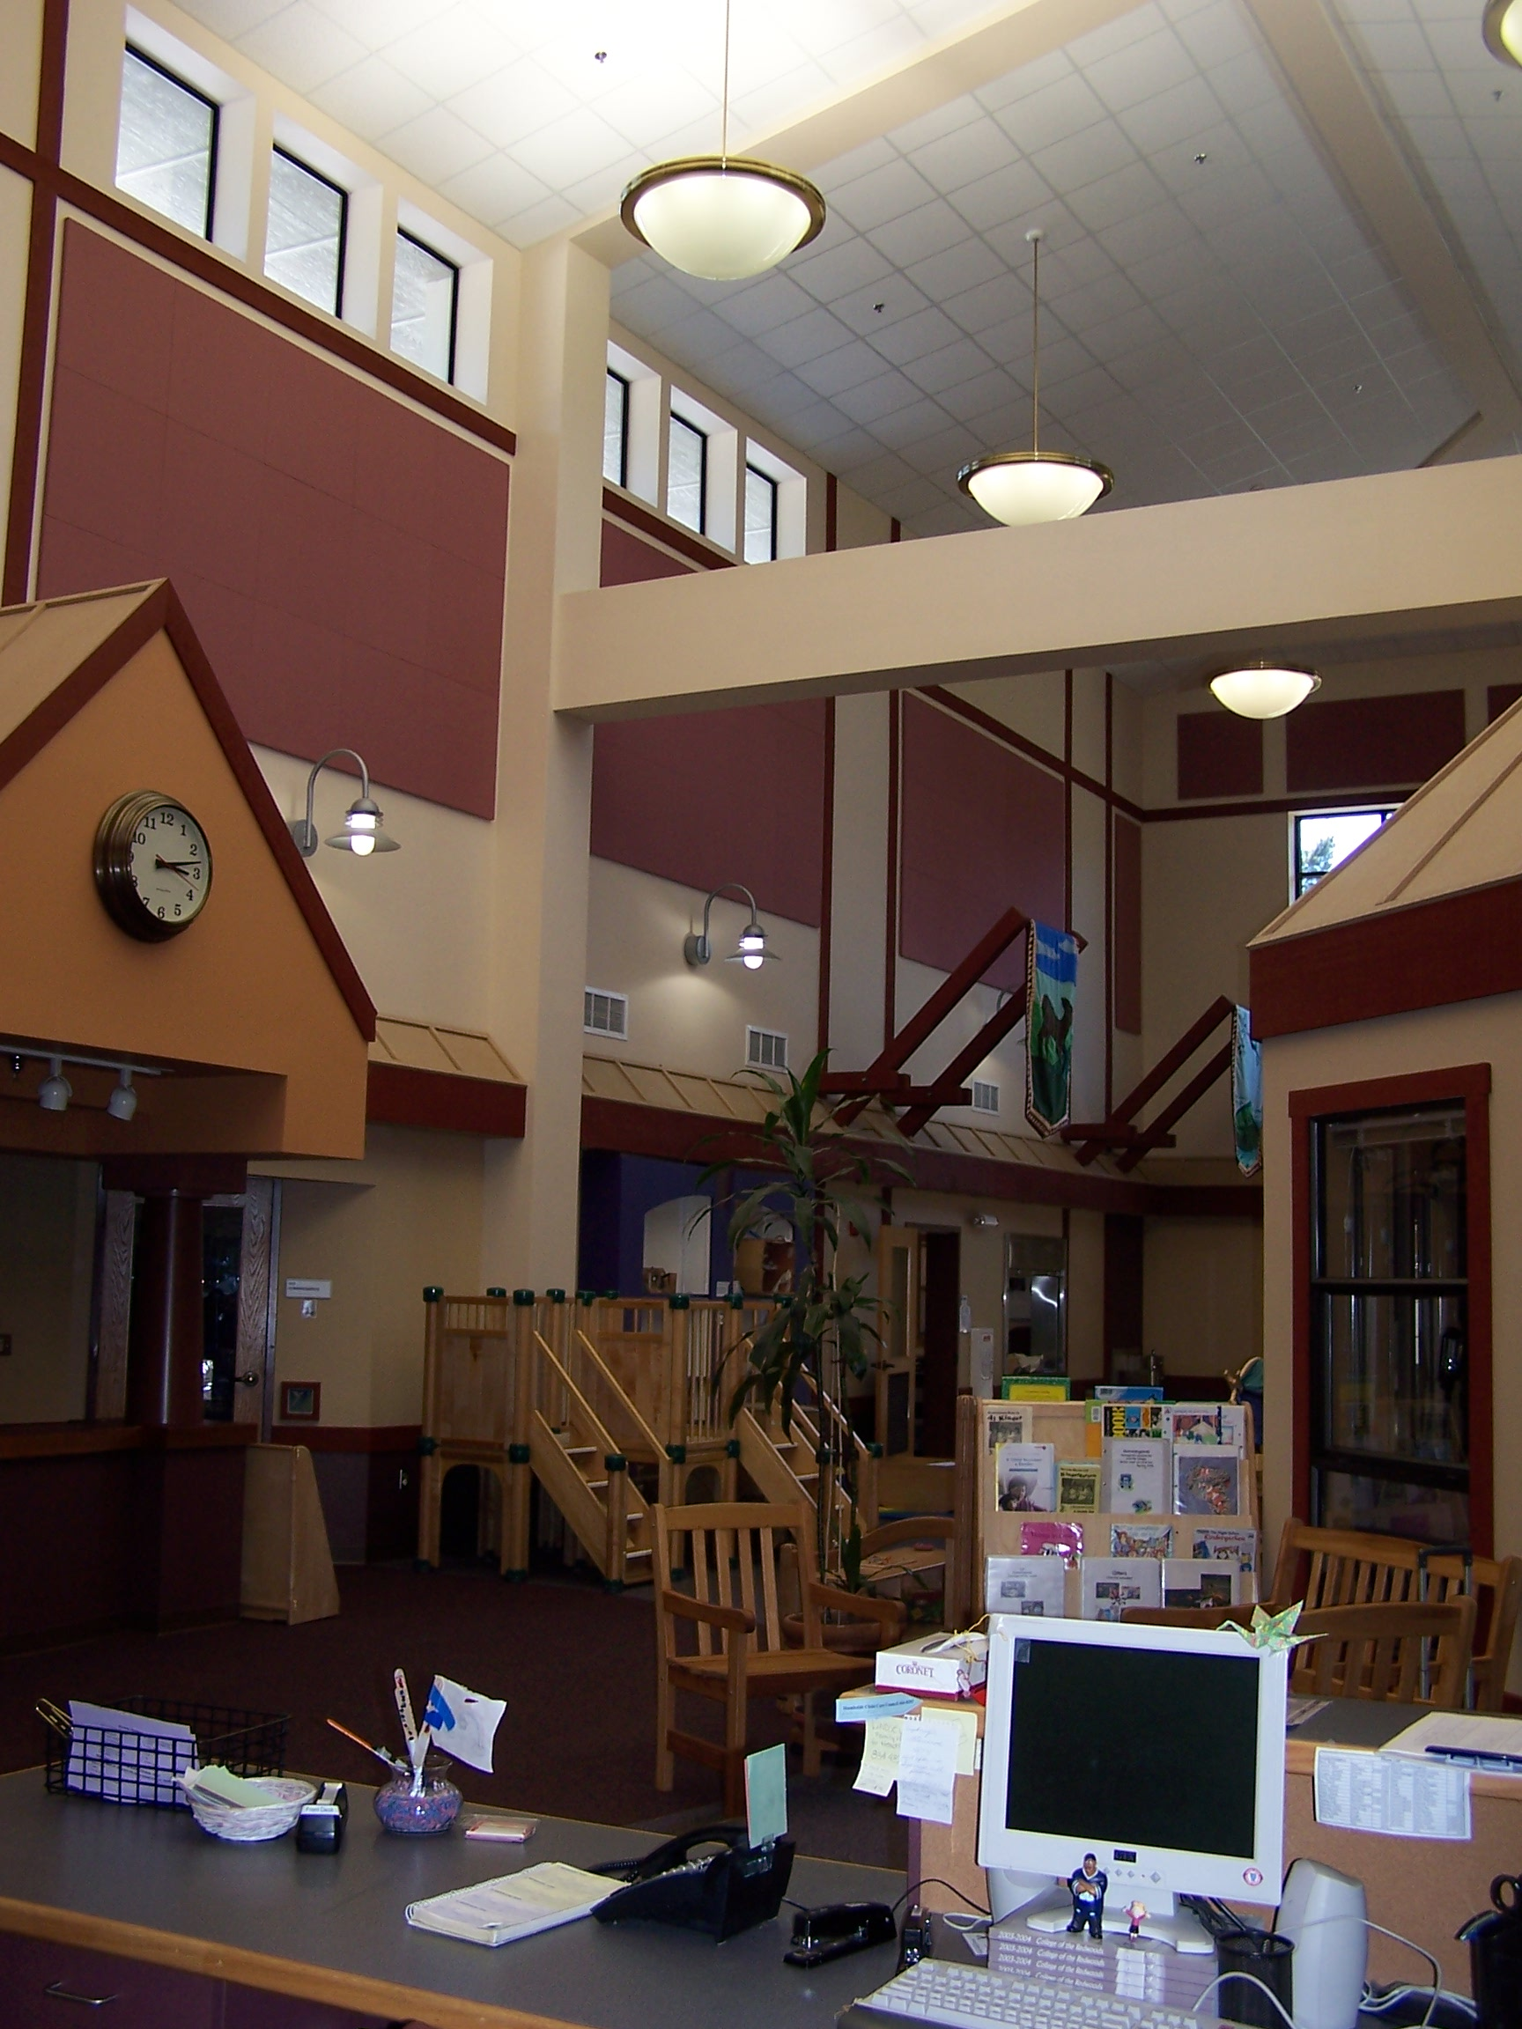
The College of the Redwoods Child Development Center opened in 1974 in a portable building behind the dorms. After several years of being filled to capacity, the building was expanded and a second classroom was added. A toddler classroom was added in 1985 with the addition of a second portable building.

The present facility was many years in planning. The original Director asked for assistance from anyone who had creative ideas. This included teachers, instructors, parents, custodians, the yard maintenance crew, and even the children had input to create the lovely building that is now home for the children, parents, students, and teachers at the Child Development Center!

Licensing Information

The College of the Redwoods Child Development Center is licensed by the State of California’s Department of Health and Social Services Community Care Licensing Division to provide an enriched developmental program for Toddler and Preschool children. The CDC is equipped and staffed appropriately for these ages and meets or exceeds all State, County, and City regulations for health, sanitation, safety, and teacher/child ratios. The CDC is owned and operated by the Redwoods Community College District for use by students, faculty, and staff of the College of the Redwoods and the community, as space allows.

Children and Families Served

The CDC serves children from two through age five who are ready for this type of group experience and who can benefit from the program. Children need not be toilet trained prior to enrollment. The CDC is operated on a non-discriminatory basis, providing equal treatment and access to services without regard to gender, sexual orientation, ethnic group identification, race, religious beliefs, national origin or ancestry, or mental or physical disability

Hours and Holidays

The CDC is open during the school year, Monday through Friday from 8:15 a.m.
to 4:15 p.m. during fall and spring semesters and through the summer as funding allows.

CHILD DEVELOPMENT CENTER GUIDING PRINCIPLES

Program Philosophy

At the College of the Redwoods Child Development Center, we believe children are capable and competent people. The CDC staff is committed to children’s potential and their enjoyment of life. The CDC embraces children’s disposition for curiosity, resourcefulness, persistence, problem solving, and creativity. We are a community of learners where children and adults explore their world together. Further, we believe that:

- Children gain knowledge and develop skills in a play-centered environment. A play-based curriculum encourages children to explore and experiment, constructing knowledge from their play. Teachers provide a variety of experiences based on the interests and development of children as individuals and as members of the group.

- The staff works in collaboration with families to create an atmosphere respectful of each child and family. Family members are welcome to become active participants in our learning community. Together we are working toward a high quality, enriching educational experience for children and those who care for them.

Play-Based Curriculum

At the CDC, children’s play is supported by the thoughtful array of activities that the teachers present. Play allows the whole child to develop. Children grow cognitively, physically, emotionally, and creatively. Teachers in a play-based program that reflects children’s changing interests and abilities, create an environment and corresponding curriculum that encourage children’s exploration. Teachers take the time to listen to children, engage them in conversations, and closely observe the ways they interact with others. Teachers use these observations to help children use observations and a deeper thought process developing cognitive and intellectual skills.

“Project Work” enables children to solve a problem or answer a question as they learn to make sense of their world. Children review their current knowledge and then, within a group they will explore research, interview, discuss, reflect, and change their point of view as they share their ideas.

The program develops relationships between the children, their families, and the adults at the center. Young children are developing trust, a sense of self, and initiative. Each child’s teacher creates a trusting relationship, which supports that child’s learning.
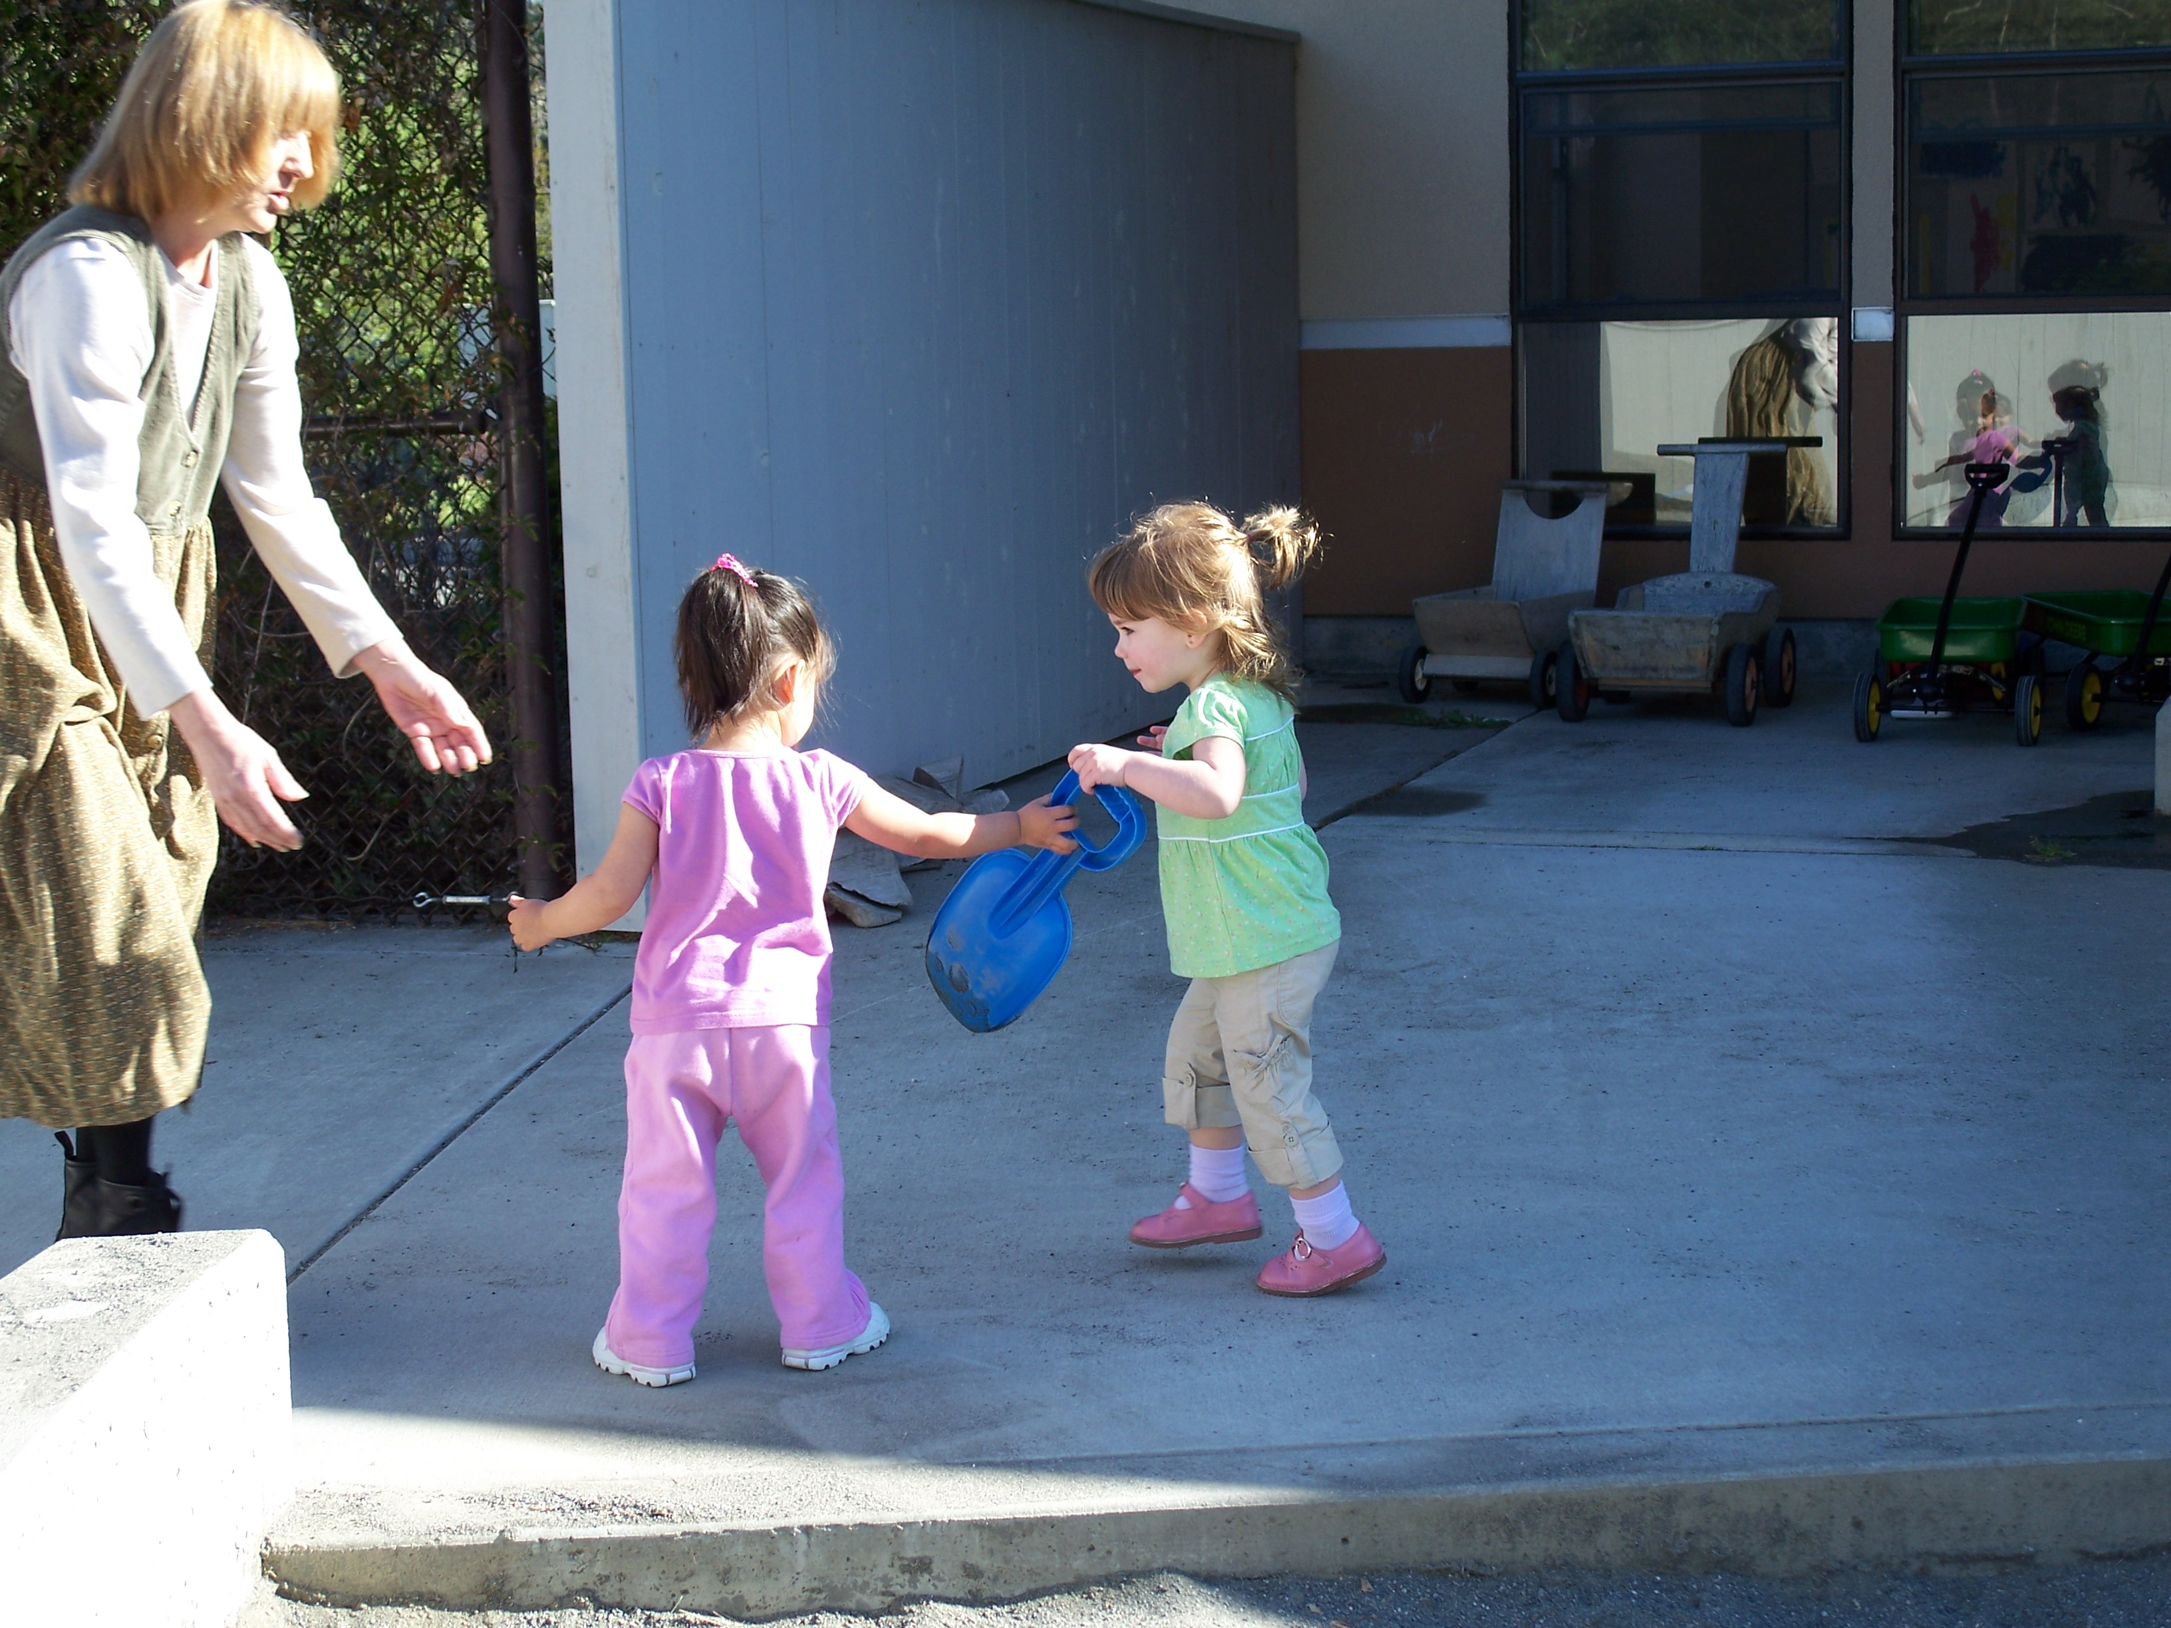
The Child Development Center’s play-based curriculum fosters an integrated community of learners.

Program Goals for Children

The CDC was established to meet the needs of children from 2 through 5 years of age. Our desire is to provide an environment in which children can thrive and find out for themselves who they are and what they can do. To do this, a child needs an environment that says:
Children are personally and socially competent
Children are effective learners
Children show physical and motor competence
Children are safe and healthy
(DRDP –desired results for children)

- Each child will develop a disposition for lifelong learning.

- Each child will be empowered to construct knowledge about their world.

- Each child will develop the ability to solve problems individually and as
a group member.

- Each child will develop self-esteem by meeting appropriate challenges.

- Each child will develop positive, collaborative relationships with their
families and with the adults and children at the CDC.

- Each child will represent their thoughts and feelings with a wide variety
of mediums.

- Children will attain the highest level of independence that is appropriate for their age.

- Each child will value the diversity of people in the world.

- Each child will develop physically, cognitively, socially, emotionally, and
creatively.

Program Goals for Families

Parent involvement is a critical component of our program. It adds to the quality of both the parent and child’s school experience. Children benefit tremendously when their parents are involved in their school. Parent involvement teaches children that their parents value their school and find it important enough to give their time and energy. Parent participation further gives parents the opportunity to feel important and included in their child’s education, and it supports open communication between teachers and parents. At the CDC, we believe that:

- Families will be active participants in their child’s care and education.

- Families will develop collaborative relationships with their child and their child’s caregivers.

- Families will be able to leave their child at the CDC with the knowledge that their child’s developmental needs are being met in a caring, nurturing environment.

- Families will have the opportunity to gain knowledge about child
development and parenting.

- Families will have the opportunity to meet and develop relationships with other families.

Building Bonds with Families

Building a strong bond with the children and their families is an important aspect of our work here at the CDC. The following is a list of things classroom teachers should do to build relationships with the families in their program. There are many more, but this list sets a minimum benchmark:

- Familiarize yourself with the home language spoken by each family. Greet the child in that language each morning.

- Use cultural information from families to enrich the learning environment.

- Ensure all families are included in all aspects of your program regardless of their family structure, racial, religious, or cultural background.

- Look for and communicate opportunities for families to volunteer in the classroom.

- Work with families to discuss shared childcare giving issues including separations, special needs, dietary needs, and daily care issues.

- Encourage parents to contribute to the evaluation process by recording observations about their child and talk with teachers about the DRDP assessment process.

- Refer parents to community resources when appropriate (encourage them to access the resource binder in the lobby if appropriate.)

- When appropriate label items in your classroom in both English and other native language represented by the children in your room.

Environment
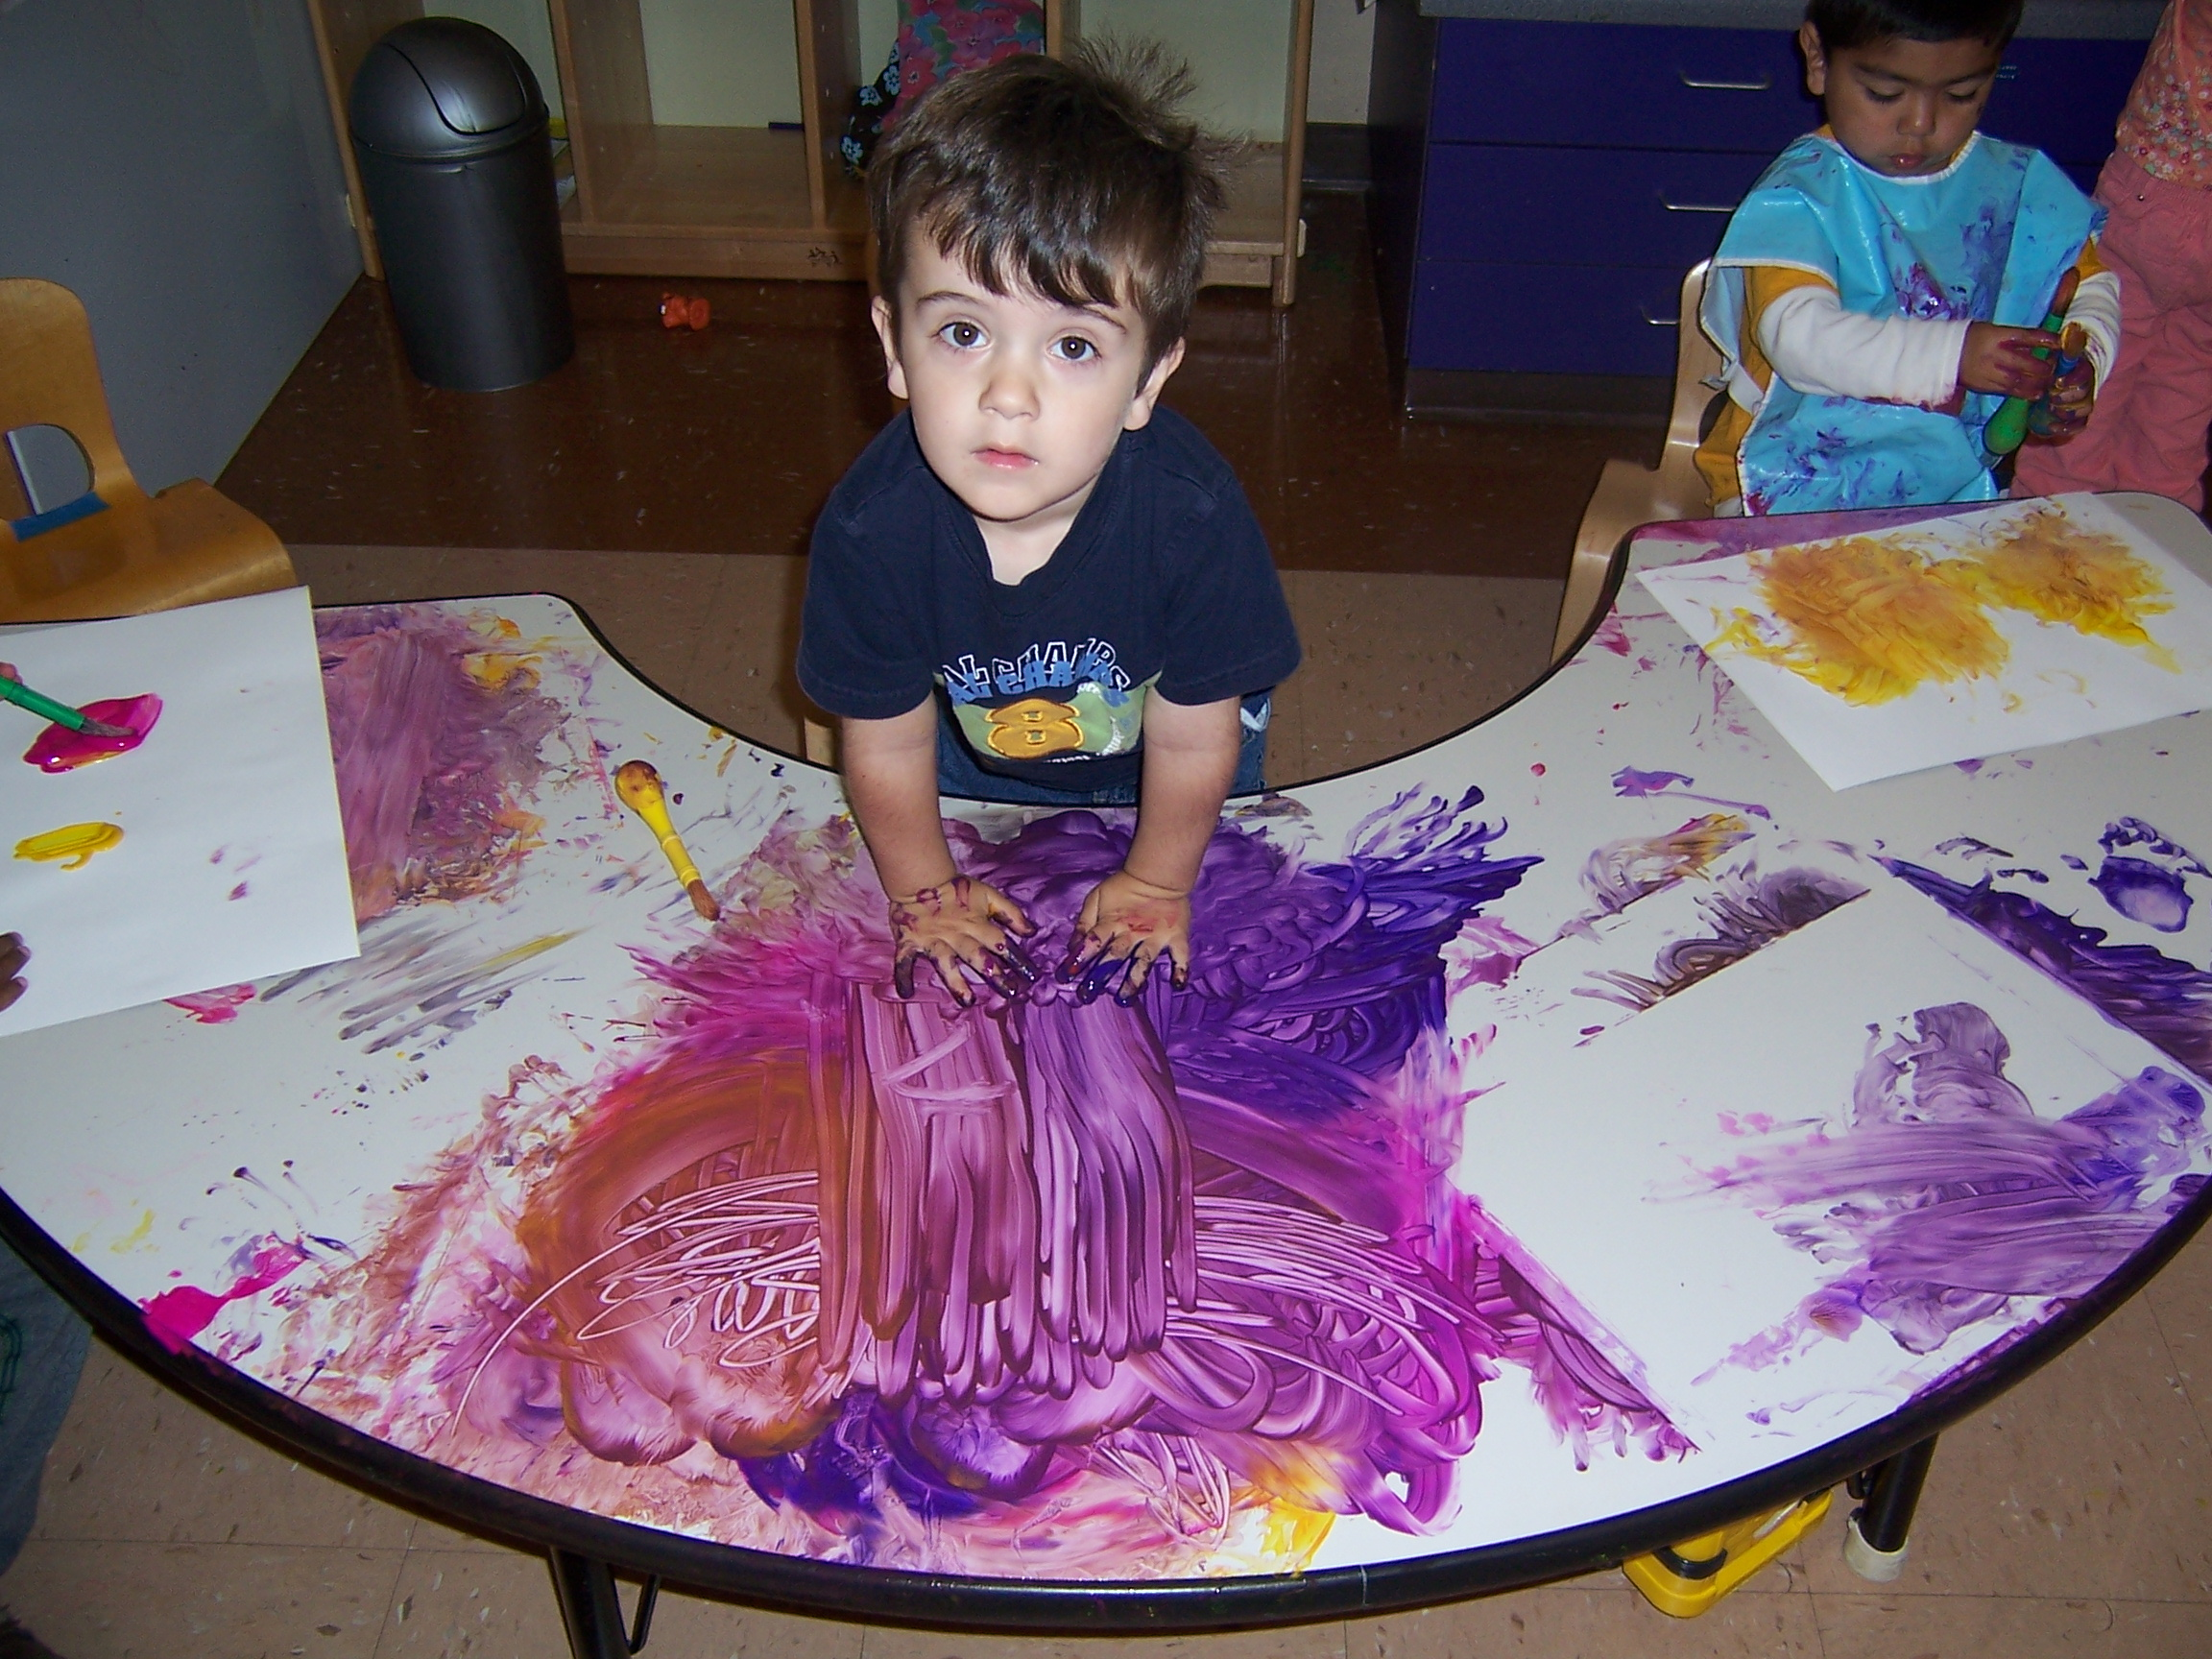
The physical environment of the CDC has been set up to enhance our program goals. It offers choice, challenges, and encourages independence. It offers avenues for cooperative play and involvement with a wide variety of materials. It also offers the opportunity to be messy. Getting involved in play activities without concern for clothing or appearance is an important aspect of a child’s learning. It is through intense interactions with the environment that children learn about the physical properties of the real world. It is also how they test ideas, sort out feelings, and learn competency ~ all-important aspects of appropriate development. We believe it is important to value interaction with the environment.

Family Responsibility

The staff of the CDC looks forward to working with parents to provide an enriching child care experience for their child. We ask the parents to assist us by assuming the following responsibilities:

- Read the Parent Handbook thoroughly.

- Meet the director.

- Attend conferences with their child’s primary teacher before the semester begins or before their child begins attending, if mid-semester. The parents should bring their child with them to this appointment.

- Provide the CDC with all required registration and enrollment forms and information. The various agencies that govern the CDC’s operation mandate the collection of this information for the enrollment of children in the program.

- Return their child’s medical assessment within 30 days of the first day of enrollment.

- Notify the CDC of an address or phone number change immediately.

- Keep child’s emergency form updated. (Their child will not be released to any person not listed on this emergency form.) Notify the CDC, in writing, 2 weeks prior to termination of childcare services or a reduction of hours of care.

- Requests for additional contracted hours must be submitted in writing and will be accommodated as space and staffing permit.

- Inform CDC of any changes in class, work or study schedule so that we will be able to reach them in case of an emergency. They should also let us know if they will be off campus.

- Sign their child in and out daily with full legal signature and the exact time.

- Bring their child to the center only during the contracted enrolled hours.

- Fill out an enrollment change form when requesting a schedule change (Additional hours on an occasional basis may be available but will need to be approved by the CDC Director or Center Assistant in advance.) They will be charged an early drop-off fee if they bring their child before his or her scheduled time.

- Pick up their child promptly at the end of the enrolled time. They will incur an additional childcare fee if they are late picking up or are early dropping off their child.

- Notify the teacher if they need to pick up their child early from a session. This will ensure that the child will not be on a walk, at a meal or involved in a prolonged or messy activity at the needed departure time.

- Stay current by carefully reading bulletin boards, newsletters and other materials as they contain important information and dates.

- Pick their child up promptly when notified they are ill.

- Keep the CDC informed of current immunizations.

- Protect their child’s skin by providing a sun hat and applying sunscreen at home or at drop-off.

- Provide only diapers (unless pull-ups are approved) and baby wipes if their child uses them.

- Label their child’s outerwear such as sweaters, jacket, and hats.

- Bring a change of clothing marked with their child’s name to keep in their cubby in case they need to be changed.

- Communicate any concerns they have about their child’s development, CDC programming, policies, complaints about the CDC or staff, legal issues concerning custody, or the dispensing of medication to the teachers or Program Director. They should convey these important pieces of information by first consulting with CDC staff.

Guidance Policy

We use positive guidance techniques that allow the children to learn from mistaken perceptions and difficult situations. The purpose of guidance is to help children learn appropriate behavior and to function successfully at school and in society. We want children to develop an intrinsic desire to act appropriately and to be respectful of themselves and others. We want to help develop the child’s problem solving skills to resolve conflict on their own and build the important skills that they will use throughout their lives.
We avoid using external rewards (such as stickers, stars, etc.) to reinforce behavior, because this can keep children from developing self-internalized motivation. Reliance on external rewards is manipulative and can be damaging. Children may view these techniques as “buying” cooperation and achievements.

Empty, non-specific praise such as “Good job!” or “I like your pretty picture!” is avoided as well for the same reasons, and because these types of comments do not describe what the child has specifically accomplished. Generic praise can make children overly dependent on your judgment about the quality of their work. Instead, we acknowledge their learning process by giving them specific feedback about what they have achieved when appropriate. For instance, instead of just saying “Good job!” when a child demonstrates that he or she has learned to write his or her name, we might acknowledge the accomplishment by simply stating what has been achieved, “You can write your name. You have been working hard on this, and you’ve done it.” This puts the emphasis on the child’s accomplishment, rather than the adult’s evaluation of it.

Initially, we work to prevent potentially difficult situations by creating a child-centered, stimulating and safe environment. We make rules clear and logical for children. When we are unable to prevent a problem, we work with the children to help them see what is causing conflict. Children are encouraged to evaluate situations and come up with their own solutions to problems. The consequences of children’s behavior flow logically from behavior. Children’s feelings are respected. Time out is not used, however it may be necessary for a child to take time away from a particular area if they are unable to follow the directions for that area. An example would be a child who continues to throw sand in the sand box after being asked to stop. The teacher might say, “I can see you are choosing to still throw sand, although I asked you to stop. You will need to leave the sandbox for now.” Corporal punishment is never used. Children are not humiliated or shamed as a disciplinary measure. Staff will not withhold or threaten to withhold food as a form of discipline.

We do not “force” apologies, because this is not effective. Apologies that do not come from the individuals involved are not real apologies. Instead, we support children in developing clear, respectful communication about their feelings and needs as well as concern for others’ rights, and encourage problem-solving skills. A teacher might ask a question like, “What could we do to help her feel better?”

If a potentially difficult situation begins, staff will take the following actions, as appropriate:

- Move close to prevent any physical harm to children or material. Avoid using a loud voice or calling out across the classroom, town square, or play yard, unless there is a critical timing issue for safety and preventing an imminent injury.

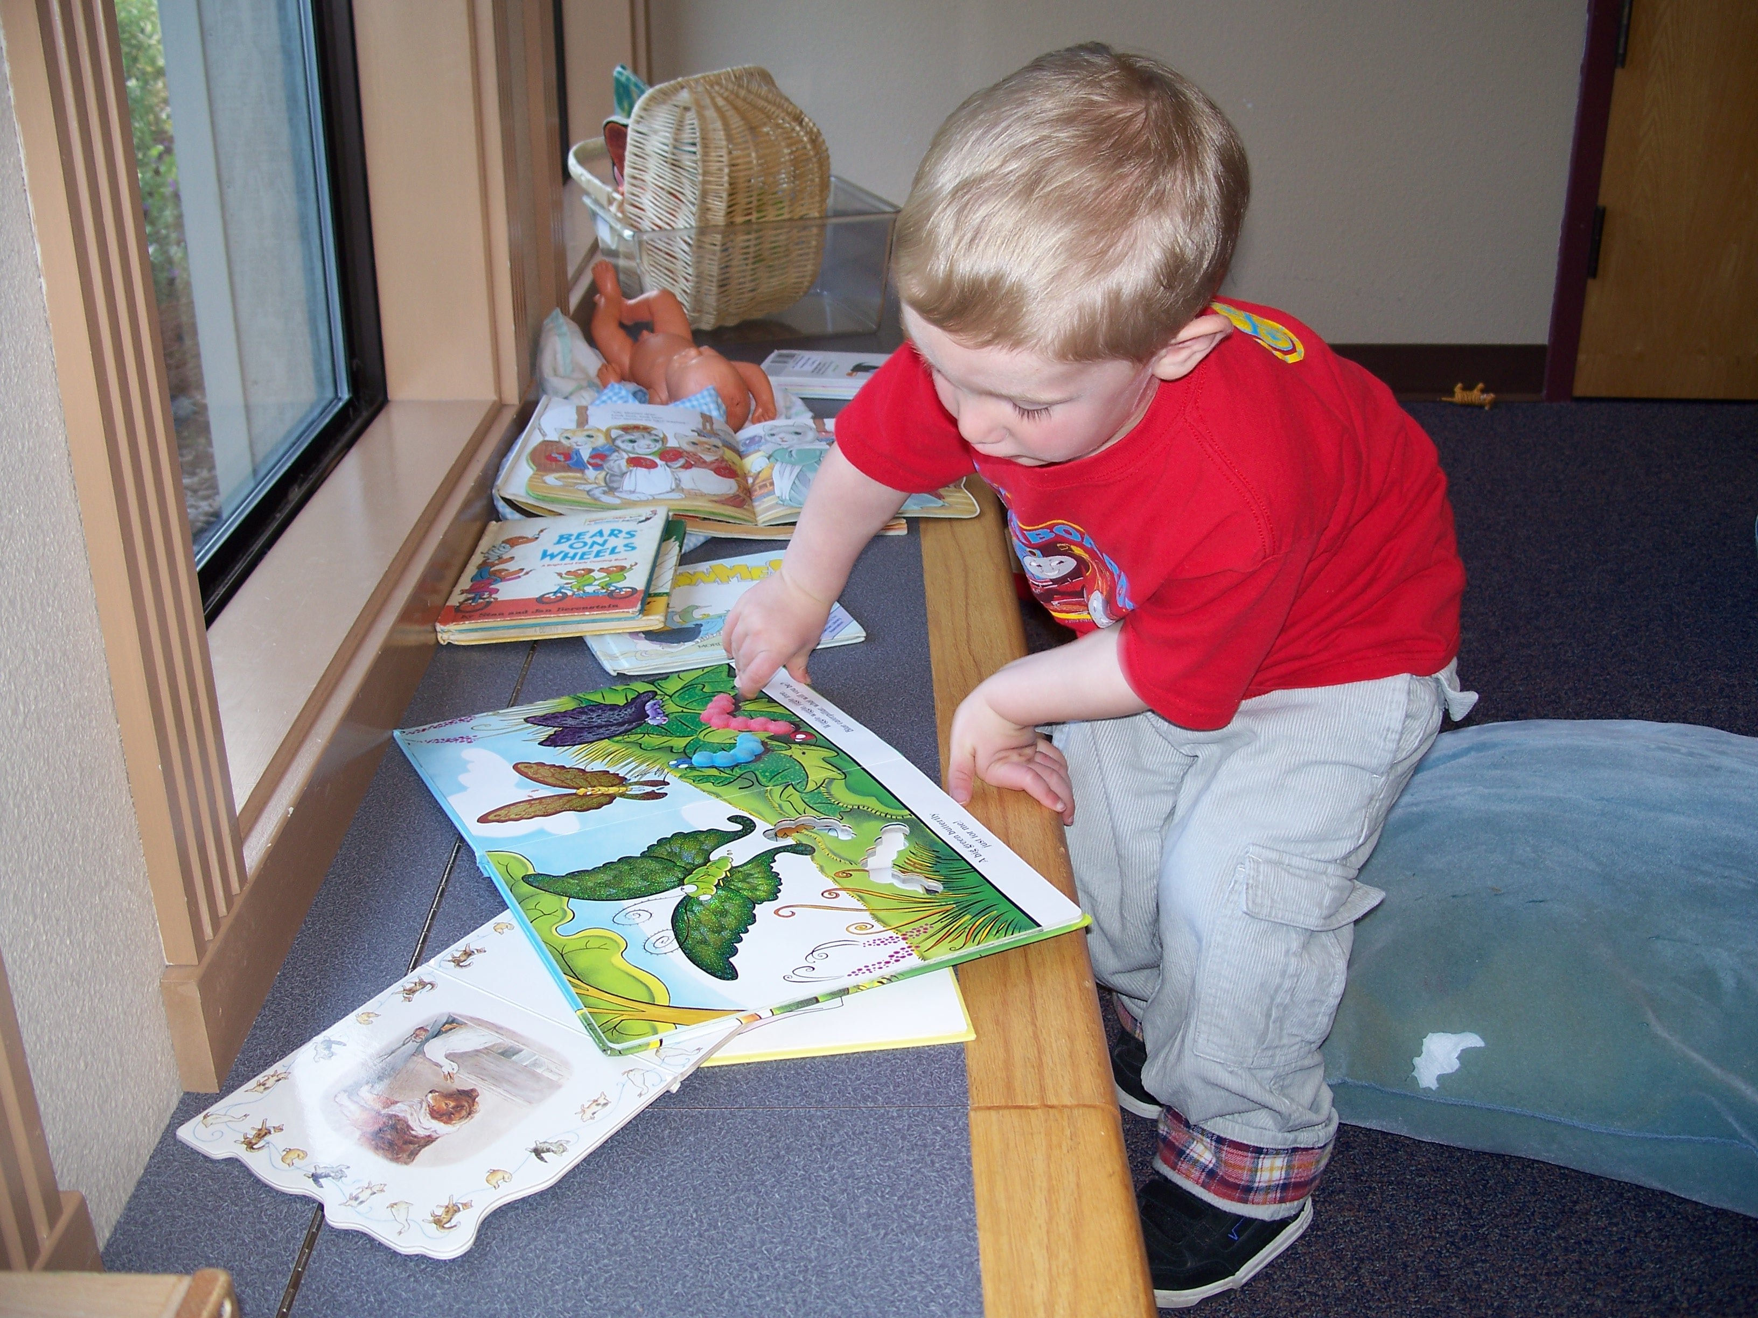
- Model calmness and use an understanding tone of voice. Get down on the children’s level. Tell the child what you see. (“I see that you both really want to play with that toy. You sound very frustrated. Johnny is crying very hard.”)

- Ask the children to tell you (one at a time) what occurred. Expect that you may hear two different stories.

- Ask the children what they would like to have happen. (“I hear that you both want to use the red truck. There is only one of them. What do you think we could do?”)

- Point out the differences between the children’s desires and ask if they can come up with a solution that will meet both of their needs.

- A child who is having a difficult time functioning within the group may be “partnered” with a permanent staff member until he or she is able to play cooperatively within the group.

- In the rare event that a child is unable to keep himself from hurting others, himself, or property, a permanent staff member may embrace the child in a way that gently helps the child calm down. While working with the child, the teacher will speak soothingly to the child until the child can return to the group. If a child is restrained for any reason, an unusual incident report must be filed with the Child Care Licensing Program Analyst.

- Never yell, demean, hit, grab, or use any physical punishment or verbal humiliation.

- If an ECE lab student or a student employee is unsure of how to handle the situation, or if it is escalating, he or she should ask a Master Teacher or Teacher for assistance.

The children and staff at the child development center must feel safe. If one of the children is unable to control their actions and avoid hurting others, they may need to be excluded from the program for a brief period to allow for collaboration between parents and staff. If the behavior continues, the parents may need to find alternate care.

Definition of Challenging Behavior
According to NAEYC the definition of challenging behavior is as follows: “Challenging behavior is any behavior that (1) interferes with children’s learning, development, and success at play, (2) is harmful to the child, other children, or adults {or} (3) puts a child at high risk for later social problems or school failure.” Examples provided by NAEYC include but are not limited to physical aggression ( hitting, biting, shoving, whacking with toys, relational aggression (“You can’t play with us” verbal bullying), tantrums, whining, testing limits, refusal to follow directions or observe classroom rules. ( 1.E.01)

Staffing Protocol and Confidentiality

The teaching staff at the CDC has training in child development and experience in early childhood education. They hold degrees and/or permits or credentials that meet or exceed the requirements of Title 5. ECE Master Teachers have the authority to provide leadership and direction to ECE lab students and student employees in their classrooms.

The permanent staff will assign activities and tasks to all other adults in the CDC based on their knowledge of the task to be completed, the needs of the children involved, the education, training and skills of the available adults and the flow of job assignments. If any staff member has concerns about a particular job which has been assigned by a supervisor, please complete it and then if you still are concerned make an appointment to talk to a permanent staff member at a time neither of you is working with children, students or families. When staff is “on-the-floor” with children, the children’s needs are primary. The CDC staff and ECE instructors have mailboxes in the office area. The ECE course instructors and the CDC staff are in close communication. Both are aware of course assignments and center policies and are working together to help ensure a meaningful field experience for students. CDC permanent staff, substitutes, student employees and ECE lab students will model respectful, professional, and appropriate behavior and positive, constructive communication skills with children, families and staff.

Students may do child observations as part of their course work. These observations may be shared with the permanent CDC staff, but not with the parents. Communication with parents is the responsibility of the Master Teacher and the Teacher. Respect the privacy of the children and families the CDC serves. In the course of working at the CDC, you may become aware of private or confidential information about children and families. Keep this information confidential. Even if you know the child’s parent outside the center, keep information you learn about the child in the center to yourself.

Never discuss children or families in front of other children, parents, lab students or observers. Be aware that there may be students in the observation rooms listening. If you are discussing a child or family with one of the permanent staff, do so out of hearing of microphones in the room or of another child or family. Children and their families should never be mentioned in front of others, away from the center or with your family and friends.

Failure to follow the confidentiality guidelines is very serious. A breach of confidentiality can be cause for your exclusion and dismissal from the CDC. If students have concerns or questions about a child, please discuss them in private with the child’s primary staff member. Even if students want information about a child’s special needs to complete a course assignment, the teachers are not at liberty to discuss this information.

Parents may try to talk to student employees and ECE students about their child’s development, the CDC program or policies, or complain about the Center, ECE staff, or legal issues concerning custody or the dispensing of medications. Student employees and ECE lab students should direct the concerned parent to a Master Teacher or Teacher. The teaching staff will share the information about Center policies, children and families in a way that does not violate confidentiality as needed in order to provide appropriate care for children.

Media Protocol

Staff and students will not use personal or outside devices such as cell phones for documentation purposes. Only class cameras or an issued iPad are to be used for assessments and class assignments. Under no circumstance is any recorded documentation to be posted to personal or public media accounts.

Supervision and Accident Prevention

Safety and prevention of accidents is a high priority.

- When a permanent employee, substitute, student employee, ECE lab student or volunteer is assigned to facilitate children’s play in a certain area inside or outside, they should remain there until relieved.

- If an individual needs to leave the area, s/he should inform a permanent staff member to be relieved of the assignment.

- If a staff members necessary departure will leave the group out of the appropriate teacher to child ratio (toddlers – 1:4, preschool – 1:8) the staff member should call the office for assistance.

- Children must be supervised at all times, in all areas of the CDC, including the bathrooms.

- Falling asleep while supervising a room of napping children is considered leaving a child unattended and will lead to disciplinary action, which may include termination.

If a safety hazard is observed in the center or in the yard, a permanent staff member will notify the Director or Center Assistant as soon as possible. They will remedy the problem or fill out a work request to have needed correction completed.

If children are engaged in activities which could be harmful to themselves, others or materials, a permanent staff member should be notified immediately. All staff must familiarize themselves with the CDC’s guidance policy. Most of our guidelines stem from these three ideas: be safe, be kind, and listen. Guidelines are enforced in ways that empower children and help them develop internal control over their behavior.

A “yard sweep” is completed each morning in which staff and students inspect and walk all around and through the yard looking for any hazards (bottles, cigarette butts, Styrofoam, garbage). The sweep must be completed before children come out to play each day.

Child Accident and Incident Issues

When an unusual incident or accident occurs, staff, substitutes, students, and volunteers must communicate with each other to ensure proper procedures are followed. If you observe an incident or accident, immediately notify the supervising Master Teacher and provide details of the accident/incident that you observed.

Whenever an incident or accident occurs, staff must communicate with each other to ensure that the CDC is adequately staffed, the Director and/or Center Assistant are informed about the situation, and that one person has all the necessary information for a follow-up debriefing

The procedure when an injury occurs is as follows:

- The teacher closest to the accident responds and communicates to nearest regular staff person, “I am dealing with_________, who has fallen, has sand in face, etc. Please watch the room/playground.” If this would leave only one teacher outside or inside, call the Director, Center Assistant or adjoining classroom for help with supervision.

- If the accident appears serious, do not move the child. Call for assistance from other staff. If the accident appears non-serious and the accident is outdoors, the teacher should ask another teacher to relieve her so she can assist the child. If the accident is inside and no other teacher is available, ask another adult to help or to call for additional help, administer first aid and write an accident report

- Be sure to complete an incident/accident report and have the parent sign the form. Press firmly enough to ensure the second copy is clear. Once signed, the second copy should be placed in the receptionists box.

- As with any situation that takes a teacher off the floor, while first aid is administered and an accident report is being completed, another adult will need to watch other children. The Director, Center Assistant, or teaching staff from adjoining classroom should be alerted to help cover.

- If injury is serious, first call 9911 from a classroom phone or 911 from a cell phone. If you are unsure if an injury is serious, first call Campus Security (# 4111). The Campus EMT will examine the child and make a recommendation.

- In the case of a serious accident or incident, a campus accident report will be completed and an “Unusual Incident Report” must be sent to Community Care Licensing (CCL). When an “Unusual Incident Report” is necessary, a call must also be made to the CCL Office within 24 hours.

- Alert office personnel to contact the parent.

MANDATED REPORTING RESPONSIBILITIES

Childcare providers are required by law (§ 11166 of the State Penal Code) to report abuse or neglect to Child Protective Services (CPS). In the event of reasonable suspicion, CPS will be notified and an investigation will be made. CPS has the authority to “observe and/or interview children, or staff, and to inspect and audit child or facility records without prior consent.” As a mandated reporter, childcare providers have absolute immunity from criminal or civil liability for reporting suspected abuse as required or authorized. The statutory duty to report is not excused or barred by the professional privilege of confidentiality. The primary intent of the report is to protect the child and help the parent.

Child abuse is defined as:
- a physical injury that is inflicted by other than accidental means on a child by another person

- sexual abuse, including both sexual assault and sexual exploitation

- willful cruelty or unjustifiable punishment of a child resulting in physical pain or mental suffering

- corporal punishment or injury resulting in trauma

- neglect, including both severe and general neglect

In the event of reasonable suspicion of abuse, the CDC will notify Child Protective Services. It is not our job to investigate or place blame. We function as a support system to the child and family during and after the investigation.

If child abuse or neglect is suspected:
- staff member must report to the supervising Master Teacher or Director within 24 hours of the suspected abuse or neglect.

- within 24 hours, a verbal and written report must be made to Child Abuse Hotline 445-6180.

- the Director will keep one copy of the reporting form for the child’s file and send one copy to the center’s administrator. The Director will provide additional detail to the administrator, as requested.

- all child abuse reports are to remain confidential.

Staff who report suspicions of child abuse or neglect where they work are immune from discharge, retaliation, or other disciplinary action for that reason alone unless it is proven that the report is malicious.

When an employee is accused . . .

Employees are held to a high standard of interactions with children and abuse of any sort will not be tolerated. This applies to a staff member’s personal child as well.

If an employee from the Child Development Center is accused of abusing a child, the following must be adhered to:

The employee will be placed on immediate administrative leave, with pay, per the CSEA contract. All steps to be followed are outlined in the CSEA contract Article XVI – Disciplinary Action beginning on page 52 of the current contract.

The event must be reported to Child Care Licensing Program Analyst by phone/email and using an unusual incident form. This report must occur no later than the following business day.

Notification of Communicable Illness

All classroom parents and staff will be notified in writing of any contagious illness exposure. The nature of the illness will be described along with suggestions for actions to be taken. Staff must call the CDC to report any illness you may contract while employed at the Center in order to determine if an exposure notice is required to be posted.

Health Department Reporting

Title 17, California Code of Regulations, §2500, requires childcare centers to notify the local health authority immediately if they know or suspect any of the following diseases or conditions:
- hepatitis • pertusis
- epilepsy • tuberculosis
- measles • scarlet fever
- meningitis • rabies
- mumps

For outbreak reporting of occurrences of unusual and rare diseases, see §2502 and §2503 of the California Code of Regulations.

Community Care Licensing Reporting

Upon the occurrence, during the operation of the facility, any of the events specified in section (a) below, a report shall be made to Community Care Licensing within the next working day during normal working hours (Title 22, §101212). In addition, an unusual incident report containing the information specified in section (b) below shall be submitted within seven days of the occurrence.

- Events reported shall include:

- death of a child from any cause
- any injury to a child that requires medical treatment
- any unusual incident or child absence which threatens the physical or emotional health or safety of a child
- epidemic outbreaks (4 or more children)
- catastrophes
- fires or explosions which occur on the premises

- Information provided shall include the following:

- child’s name, age, sex, and date of admission
- attending physician’s name, findings and treatment, if any
- disposition of case

All staff is responsible for reporting the occurrences mentioned above. The local CCL office is located at:

Community Care Licensing
749 F Street
Arcata, CA 95521
(707)826-9961

HEALTH PROCEDURES

Daily Health Screening

We are required to make an informal health inspection as each child arrives at school (Title 22, §101326.1). While greeting the child, the designated teacher shall get on the child’s level, touch the child’s skin and look at his/her general appearance. If the child appears ill, the teacher should talk to the parent to determine the child’s health status before the child is left at the Center for the day. Things to look for when doing a health screening include:

♦ listlessness
♦ excessive coughing or colored runny nose
♦ feverish appearance or warm to the touch
♦ signs of injury such as noticeable bruises or cuts
♦ visible, unexplained rash
♦ parent reports child is not feeling well

If a child is not well enough to participate fully in the day’s activities, including outdoor play, the parent may not leave the child at the Center. A teacher has the authority to send a child home based on their assessment of the child’s health.

If the child has had any of the following symptoms or illnesses in the previous 24 hour period, the child may not return to the CDC until symptom-free for 24 hours or the child has been prescribed medication and has received at least one dose and is well enough to participate fully in program.

♦ fever of 100° F or higher ♦ rash of unknown origin
♦ impetigo ♦ nausea or vomiting
♦ diarrhea ♦ conjunctivitis
♦ head lice/nits ♦ severe cold or flu symptoms
(CDC has a no nit policy)

In the event a child develops any of the symptoms listed above, office staff will contact the parent to have the child picked up. A child will not be allowed to remain at the CDC if any of the above symptoms are present.

Re-admission to School

Good communication with parents is essential when determining their child’s health status. Upon the child’s return to school, the admitting teacher must question the parent regarding the child’s symptoms to assess whether or not to readmit the child. It is important to follow common sense guidelines in this assessment. Tact and discretion are called for when assessing reentry to the CDC.

Ask the parent questions regarding the progression of symptoms, any medication given, and time the last medication was given. Consider the appearance of the child – does the child look well? Question the parent thoroughly on the previous day’s symptoms. Did the child improve as the day went on or did the symptoms worsen? Ask the parent if the child has been given any medications which may mask his or her symptoms.

It is important to decide if a child may remain at the CDC while the parent is present. If the teacher decides not to allow the child to stay at school, the parent must take the child at that time. If you are not sure about re-admission, it may be helpful to point out your areas of concern to the parent and then ask, “Do you feel your child is well enough to come back and have a good day?” Remember, parents usually DO know if their child is really well enough to be at the Center. They may lose their objectivity because of school assignments or job pressures, but when asked direct questions regarding their child’s health, they are usually helpful. REMEMBER, in most cases, the decision to readmit is a co-decision involving parent, teacher and child. However, the teacher is responsible for the health of the general classroom population and therefore must make the final decision when readmission is questionable. When in doubt, request a second opinion from a Master Teacher or the Director.

Hand Washing

All staff, participating adults, and children must wash their hands frequently while at the CDC. Germs grow in warm, moist places, especially on palms, between fingers, and under nails. Moist germs enter the body through the mouth or nose. Hand washing removes germs from hands before they touch food or utensils which go into the mouth. In a childcare setting, the viruses responsible for colds circulate rapidly, especially during the winter months when we tend to remain indoors for longer periods. The virus concentration in respiratory secretions is usually highest 2 to 3 days before a person develops symptoms of illness. As a result, the classroom air and everything your bare hand touches picks up germs. Children should be instructed and assisted to wash their hands just as adults. The proper hand washing procedure is:
- wet hands with running water
- use liquid soap
- wash from front to back to finger tips using a scrubbing, over-and-under motion (continue washing hands for approximately 20 seconds) and rinse with running water
- dry hands with a paper towel
- use paper towel to turn off faucet handle

Wash hands before:
- beginning work with children for the day
- any handling, preparation, or consumption of food
- diaper changing or assisting with toileting
- leaving the CDC for the day

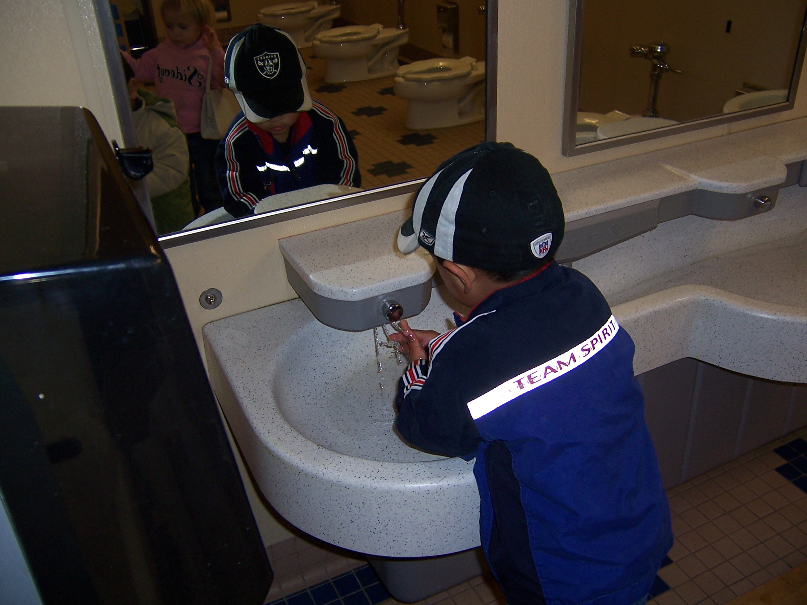
Wash hands after:
- wiping or blowing noses
- diaper changing or assisting with toileting
- removing disposable latex gloves
- preparing and/or consuming food
- personal toileting
- yard supervision
- handling any soiled paper or clothing
- sneezing or coughing into one’s hand
- contact with bodily fluids (vomit, urine, etc.)
- handling pets

Sanitation Procedures

All staff must follow appropriate sanitation procedures for the health and safety of everyone attending the CDC. For example, toxic materials, soaps, detergents and cleaning supplies must be stored where inaccessible.

Please adhere carefully to the following schedule. The bolded areas show tasks that must be completed by classroom staff. Those not bolded will be completed by the maintenance department during their nightly cleaning.

Cleaning and Sanitation Frequency Table
Area | Frequency | Party Responsible
Countertops/tables | Daily and when soiled | Staff
Food preparation and service surfaces | Before and after contact with food activity; between preparation of raw and cooked foods | Cook/Staff
Floors | Daily and when soiled | Maintenance
Door and cabinet handles | Daily and when soiled | Maintenance/Staff
Carpets and large area rugs | Vacuum daily when children are not present. Clean with a carpet cleaning method approved by the local health authority. Clean carpets only when children will not be present until the carpet is dry. Clean carpets at least monthly in infant areas, at least every three months in other areas and when soiled. | Maintenance
Windows | Interior and exterior door windows cleaned daily. | Maintenance
Small rugs | Shake outdoors or vacuum daily. Launder weekly. | Maintenance/Staff
Utensils, surfaces, and toys that go into the mouth or have been in contact with saliva or other body fluids | After each child's use; or disposable, one-time use utensils or toys. | Cook/Staff
Toys | Weekly and when soiled | Staff
Dress-up clothes not worn on the head | Weekly | Staff
Sheets and pillowcases, individual cloth towels (if used), combs and hairbrushes, washcloths, and machine-washable cloth toys | Weekly and when visibly soiled (used only by one child) | Staff
Blankets, sleeping bags and cubbies | Monthly and when soiled | Staff
Hats | After each child's use (or use disposable hats that only one child wears) | Staff
Mops and cleaning rags | Before and after a day of use, wash, rinse, and sanitize mops and cleaning rags. | Maintenance
Hand washing sinks, faucets, surrounding counters | Daily and when soiled | Maintenance
Soap dispensers | Daily and when soiled | Maintenance
Toilet seats, toilet handles, cubicle handles and other touchable surfaces, floors | Daily or immediately if visibly soiled | Maintenance
Toilet bowls | Daily | Maintenance
Doorknobs | Daily | Maintenance
Changing tables | After each child's use | Staff
Any surface contaminated with body fluids: saliva, mucus, vomit, urine, stool, or blood | IMMEDIATELY | Maintenance/Staff

Adapted From: Healthy Young Children, A Manual for Programs, NAEYC, 2002.

Latex/Vinyl Gloves

The following guidelines are provided for your information. Gloves should be worn under the following circumstances:
- blood related injuries
- when the adult has a break or cut in the skin
- when assisting with toileting or diapering (while hand washing provides protection against infection transmitted through feces, gloves are suggested as there are situations where blood may not have been anticipated or recognized)

Gloves used for infection control should be made of latex and be disposable. Gloves should never be washed or reused. A new pair of gloves should be used for every situation. Gloves should be turned inward by removing from the wrist to fingers, wrapping one glove inside the other while removing, and disposed of immediately in a covered, lined trashcan.

Medication Policy

The CDC permanent staff may administer prescription medicine and over the counter medicine to children in certain situations. The parent must fill out the medication form and notify the child’s teacher and the Director, or Center Assistant.

If a staff member or student needs to take prescription or over the counter medicines while at the CDC, they should do so out of sight of any children.

CDC staff is not authorized to administer treatments with nebulizers. If a child requires nebulizer treatments, the parent or guardian will be required to administer them.

All allergies and/or special needs must be indicated on the Emergency Form and on the Health Record Physical Form.

All parents should apply sunscreen to their child in the morning before leaving the center.

Rest Needs & Naps

The CDC has established routines to meet children’s needs for rest. Children have their own center-provided rest mat and individual bedding. Teachers will consult with parents to discuss individual rest needs. Parents are encouraged to bring in articles that may enable the child to feel more comfortable at rest time. Ensure a child’s face remains uncovered while napping.

Safety and Licensing

The child’s safety is very important to us. We want the parents to feel comfortable with their child’s care and development. We encourage the parents to visit the center at any time. Appointments to visit the center for enrolled parents and guardians are not necessary. The teaching staff put the children’s needs first. If the parent or guardian would like an opportunity to talk privately with a teacher, we will be happy to arrange a time that is convenient to both of them.

The parent will have completed an Emergency Form that instructs CDC staff whom to contact in the event of an emergency. This form will include the names of people authorized to pick up their child from the CDC. The staff should not release a child to anyone not listed on these forms. If the staff is not familiar with the person designated to pick up a child, they should require picture identification. Parents should update the emergency form as needed.

Emergency Medical Care & Procedures

If an emergency should arise and if time permits, the following steps will be taken:
- Staff will attempt to reach the parents by phone or through the campus security office.
- Staff may attempt to reach the persons listed on the child’s emergency form as “additional persons who may be called in an emergency”.
- Staff may call the child’s physician.
- Staff may call Campus Security at 4111.
- Staff may call 911.

If the staff person in charge at the time of the emergency does not believe there is time to make all the calls listed above, the child will be taken by ambulance to the emergency room and phone calls will be made from there.

Earthquake and Fire Drills are held regularly at the CDC. Each room has a fire evacuation route map posted with exits clearly marked.

Nutrition Program

The CDC participates in the Child Care Food Program. This is a federally funded program to serve young children. Staff sitting at tables should eat a small portion while supervising the children. If the staff desire additional food, they must bring their own from home, or wait until all children have been satisfied.

Our meal times are as follows: breakfast – 9:00 a.m., lunch – 12:00 p.m., afternoon snack – approximately 3:00 p.m.

- Liquids and foods that are hotter than 110 degrees F must be kept out of children’s reach.

- A staff member will sit with the children during a snack or meal to supervise and while eating a very small portion they demonstrate healthy eating habit.

- Children and adults must thoroughly wash hands before and after meals.

- Model appropriate table manners and facilitate pleasant conversations among children.

- Children are encouraged, but never forced, to try a taste of each of the food items that are available.

- Children under 4 years of age will not be served: hotdogs, whole grapes, popcorn, nuts, hard pretzels, raw peas, spoonfuls of peanut butter, and chunks of raw carrots or meat larger than what can be swallowed whole.

- Everyone is expected to clean up his or her own dishes after each meal. Avoid negative, alarmed reactions or “Uh-ohs!” when children accidentally spill something. Children are learning these self-help skills as part of our curriculum. If there is a spill, handle it in a positive, matter-of-fact manner as the children are assisted in cleaning it up themselves.

- A work-study student or classroom assistant should supervise as children scrape their plates and neatly stack them in the dirty dish tub.

- Send uneaten food back to the kitchen rather than throwing away in classroom garbage cans. Discarded food has to be thrown away in a lidded receptacle.

Toddlers
Toddler aged children may need staff assistance when they first learn to serve themselves through “family-style” meals. Teachers should watch to ensure serving spoons do not become contaminated. Staff cut foods into pieces no larger than 1/2-inch square for toddlers/twos, according to each child’s chewing and swallowing capability. Toddlers are not to carry bottles or cups around the room with them while they are crawling or walking. Bottles are not to be given to children at naptime. Staff will work with parents to inform them about the dental problems related to Baby Bottle Mouth.

Preschool
We have “family style” meals, with serving bowls and pitchers. Staff members sit down with the children and encourage them to put a portion on their plate and pass the serving dishes around. Children learn to serve their own food and pour their milk. Watch to ensure the children do not place serving spoons in their mouths. Sometimes the preschool-aged children will rotate the job of setting the tables for lunch each day.

As a requirement of our Food Program, a physician form must be filled out listing the food that will be substituted, must document all food allergies, including milk. Parents may request a soy substitute for liquid milk without a physician’s form, but must do so in writing in the office.

EMPLOYEE HEALTH AND SAFETY

No employee wants to have an accident or cause someone else to have one, but carelessness on the part of an employee can result in accidents and personal injury. Safety, on the other hand, is the proof of an employee’s skill and good judgment. When employees perform their work in a safe way, they have accepted the personal responsibility of protecting themselves, their fellow workers, and the CDC’s equipment from accident or injury.

In order to form the habit of working safely, you should do the following:

- report all dangerous conditions
- report all accidents, even minor ones
- suggest ways to prevent accidents

Safety Practices

It is the policy of the Redwoods Community College District to provide safe working conditions for all employees. The College of the Redwoods Child Development Center is responsible for:
- providing a safe environment for children, teachers, students, and parents
- maintaining a safe environment
- enforcing all regulations
- providing safety information in writing to all employees

Storage

Proper storage is essential for safety purposes as well as ease of locating specific materials when needed. Remember to:
- stack all materials safely inside cupboards and on shelves
- always return materials to their proper storage location
- maintain all storage areas in a safe and orderly fashion

Housekeeping

The foundation for a safe and pleasant work place is good housekeeping. Remember to:

- store materials safely in cupboards or designated storage area
- return equipment and materials to their proper storage area after use
- clean up all spills immediately (refrigerator, shelf, floor, etc.)
- exercise good housekeeping within employee break and work areas
- make sure that the classroom is tidy and that materials are properly stored at the end of each work day
- make a visual safety check of the classroom and yard when working as the opening teacher

Lifting and Carrying

Extreme caution is necessary whenever you are lifting and carrying heavy objects and children. Employees need to be aware of the proper methods to use when lifting and carrying to avoid injury or stress.

On the Job Injuries

If you have an on-the-job injury, you must comply with the following:

- report the accident as soon as possible to your supervisor (preferably before seeking medical assistance)
- complete a Report of Employee Injury Form
- notify all medical providers that this is a work related injury

EMPLOYMENT INFORMATION

The College of the Redwoods Child Development Center maintains a policy of non-discrimination with employees and applicants for employment. The CDC promotes the hiring of qualified individuals without regard to race, color, religion, national origin, sex, sexual orientation, marital status, age, physical or mental disability, or status as a Vietnam Veteran provided they meet the requirements established for the position.

Sexual harassment is a form of unlawful discrimination. Sexual harassment includes unwelcome sexual advances, requests for sexual favors, and other verbal, written, visual, or physical conduct of a sexual nature which makes the work or educational environment offensive, hostile, intimidating, or unpleasant or which interferes with work or academic performance. The College of the Redwoods Child Development Center endeavors to provide families and employees with an educational work environment free from sexual harassment and other prohibited discrimination. Families and employees are expected to adhere to a standard of conduct that is respectful and courteous to fellow employees and families and the public. We will not tolerate sexual harassment. If you need to file a sexual harassment complaint, contact the Staff Diversity & General Equity Coordinator at 476-4144.

Master Teacher, Teacher and Assistant Teacher, Nutrition Assistant, and Center Assistant positions are permanent employees of the college. Their working conditions are articulated in a classified collective bargaining agreement.

Substitute teachers are considered temporary/part time employees and are employed at the discretion of the assigned supervisor (CDC Director). Substitute teachers may be re-hired each school year based on prior year performance, classroom staffing requirements, and budgetary considerations.

Employee Requirements

Upon offer of employment at the CDC, all employees are required to complete/provide the following:

- Personnel Record/Application
- Health Screening Report (LIC 503)
- verification of clear TB test or chest x-ray
- receipt for Life Scan Service (BCII 8016)
- Criminal Record Statement (LIC 508)
- Child Abuse Index (LIC 198)
- Notice of Employee Rights (LIC 9052)
- college transcripts (unofficial transcripts are acceptable, if legible)
- verification of training and certification in First Aid and CPR

CPR requirements: Effective January 1, 1995, the State Legislature amended the SDSS Health and Safety Code (§1596.866) to require all day care centers to have at least one staff member who has current certification in pediatric first aid to be available at all times when the children are present at the facility. NAEYC standards requires at least one staff member with current certification to be with each group. All permanent staff is mandated to meet this training requirement. Training must be provided by the Red Cross, the American Heart Association, or a training program approved by EMSA. Course completion certificates shall be kept on file at the CDC, and training must be renewed by the employee, as shown on the course completion certificate.

Staff Orientation

Prior to assuming job duties, all employees will be provided orientation. The Director will provide the following information:

- Staff Handbook
- Parent Handbook
- review basic Center policies
- Center philosophy, values, and goals
- expectations for ethical conduct (NAEYC Code of Ethics)
- health and safety policies
- where and how to obtain supplies that are not located in the classroom
- location of time sheets and other forms
- tour of the CDC
- child abuse and neglect reporting procedures
- NAEYC program standards

Master Teacher (or Director) will provide the following information:

- specific guidance in classroom procedures
- discipline/guidance policies
- classroom rules
- outside safety rules
- emergency/evacuation routes
- daily schedule and activities
- curriculum planning and implementation
- location of supplies/materials within the classroom
- developmentally appropriate practices

Program materials given for review, to keep, to know, and to practice:

- Staff Handbook
- Parent Handbook
- specific job responsibilities as outlined in job description
- College calendar
These items are also located on the College of the Redwoods website.

Staff Development
Staff meetings are conducted to facilitate ongoing communication and training concerning the Child Development Center program (curriculum, classroom management, daily activities, plans for individual children, etc), early childhood theory and practice, child development, etc. Staff or team meetings are held at least monthly. Staff meeting attendance and participation are an integral part of your job as a member of the teaching staff. Open communication, on-going evaluation, sharing of ideas and active listening have a greater impact on the quality of our program than any other single component. Attendance at staff meetings is mandatory unless previously excused. All staff are paid to attend any staff meetings not conducted during normal work hours.

All staff are expected to be advancing through the steps of the Child Development Permit Matrix as indicated in your employee contract.

Designation of Authority

In the Director’s absence, the designated Master Teacher will assume full program responsibility. In the Director’s absence, program responsibility is passed on to a second designated Master Teacher. Full program responsibility means supervision and accountability for all teaching assistant actions, maintaining a safe environment, and protecting the physical safety of each child,

Designation of responsibility for program further entails familiarity with all emergency procedures in case of fire, earthquake, or other natural disaster; or in the event of child injury, illness, or parent failure to pick up a child.

AT NO TIME MAY SUPERVISORY STAFF LEAVE THE BUILDING SITE WITHOUT VERBAL TRANSFER OF AUTHORITY TO THE NEXT IN CHARGE.

Work Schedules and Assignments

Hours of employment are determined based on classroom need. Unless otherwise requested to alter your schedule by the Director, you are expected to adhere to scheduled hours. Time off for appointments must be cleared by the Director one week in advance, if possible.

Time Sheets

Permanent employees must complete and sign a Permanent Employee Timesheet (multi-part NCR), which is due the last workday of the month.

Substitute teachers and Work Study student employees must complete and sign a Temporary Employee Timesheet-salmon for Substitutes and Green for Work Study- which is due on the 20th of each month. These employees are responsible for signing in upon arrival and signing out when leaving each workday. Hourly employees must sign out for a ½ hour lunch break, if taken (mandatory if working more than 6 hours). Timesheets will be collected, signed and forwarded to Payroll on or about the 21st of each month. It is the employee’s responsibility to complete his/her time sheet. Incomplete timesheets will be forwarded to Payroll as is.

Paychecks

Permanent employees are paid once a month. Paychecks are available for pick-up at Payroll on the last workday of the month. Draft receipts are delivered to staff mailboxes on the last workday of the month. Permanent employees may also request “No Receipt” from payroll and access their payroll information electronically.

Temporary and student employees are also paid once a month. Paychecks are available for pick-up at Payroll on the 10th of the month. If the 10th falls on a weekend or holiday, paychecks will be available on the last workday before the 10th.

STANDARDS OF CONDUCT

The staff at the College of the Redwoods Child Development Center functions as a team. Groups of people who are working together for any purpose require certain guidelines pertaining to their conduct and relationships. Accordingly, we ask that all of our employees be aware of their responsibilities to the Center and to co-workers, and to engage in direct communication and constructive criticism. All staff must assume responsibility for the following guidelines for safety and well-being of everyone at the CDC.

Work time

Work time is for working! Any conduct that interferes with the work time of a staff person is not acceptable, including the use of cell phones for talking or texting. Employees are expected to be punctual in their arrival and when returning from breaks.

Work Performance

Employees are expected to put in a fair day’s work. Unsatisfactory work, poor performance, producing work below standard, loafing or excessive time away from the job, permitting avoidable waste, and lack of cooperation jeopardizes our children and other staff. All staff members are evaluated at least annually.

Attendance, Permanent Employees

Punctuality and dependability are of prime importance to the efficient running of the Child Development Center. When employees are late or absent, the Center cannot continue to function with the same degree of efficiency that is possible if every employee is on time and at work. If it becomes necessary for you to be late to work for any reason or to be absent from work because of personal business, illness (self or family), or death in the family, you are expected to follow the procedures listed below:

- Submit a Classified Employee Time Off Request to the Director, a week in advance, whenever possible.
- In the case of illness, call the Director at home prior to 7:00 a.m. and leave a message on her voice mail.
- Notify the Director as soon as possible when an appointment or a death in the family requires you to be absent from work.
- Try to make non-emergency appointments during non-work hours or during non-peak hours.
- When an absence will be longer than one day, notify the Office daily or as needed to provide information as to the date of your probable return to work.
- A release to return to work from a physician may be required if an employee takes more than three consecutive days off for illness.

Attendance, Student Employees and Lab Students

The CDC staff plan on student employees and assigned lab students who participate in the classroom to be present during assigned work schedule or lab hours. Be prepared to participate during your scheduled time. If you are unable to be present or will not be on time, notify the CDC Office as soon as possible.

If you need to make up for lab hours missed due to illness, you must sign up for those times with the Lab Instructor, Center Assistant or Director. There are limited times available during the last two weeks of the semester, so plan ahead and make up missing labs as soon as possible.

Attitude

All children, parents, and visitors should be treated with kindness, friendliness, patience, and respect. Staff should refrain from gossip, loud talking and other unnecessary noise and forms of conduct, which could disturb the program and detract from the professionalism of the CDC. Staff should come in with a happy, joyful attitude. Personal issues are not to be reflected in classroom interactions and attitudes.

Confidentiality

It is contrary to the interest of the CDC and those we serve to give out information regarding children and their parents. Such information should be held in strict confidence and should not be discussed with anyone outside the Center. Inside the Center, such information should be discussed only when it will benefit the care and education of the children and parents we serve. At no time will staff discuss individual children or personnel issues with parents at the CDC or outside the work environment. Staff are not to discuss challenges or concerns in the presence of any child. Maintaining professional conduct is expected of all employees at the Child Development Center. Refer any inquiries about children, their performance, and/or parents to the Director.

It is important to be aware that voices carry and conversations may be overheard in other areas of the CDC.

Confidentiality also applies to written communication including, but not limited to, assessments and enrollment documentation. All assessments and enrollment documentation is to be kept out of the reach of children and other adults.

Expectations of Professionalism
All program staff members are expected to maintain a clean and professional appearance that reflects positively on the program and in a way that is appropriate for working with young children. We wear clothes that are comfortable, safe, washable, and which cover our bodies discreetly due to the activities we are engaged in throughout our day. The child development staff members are role models for children, parents and our early childhood colleagues and it is important for our center to reflect pride and professionalism.
A list of items that are inappropriate at the child development center include but are not limited to the following:
- Any shirt or blouse that exposes the midriff, low cut exposing cleavage, or is transparent. No halter or tube tops. Any t-shirt with offensive language, depiction of drugs, tobacco, alcohol, weapons, or scary pictures etc.
- Any pants, slacks, shorts or skirts that are ripped or torn. Any attire that exposes your bottom from above or below. No short shorts, miniskirts or excessively short dresses. Leggings and yoga attire are not pants and should not be worn as such.
- Footwear should be comfortable and not restrict quick movements. No heeled shoes over 2”. Flip flops, sandals, and other footwear without back straps are highly discouraged.
- Excessive perfumes, aftershave, or body odor is offensive to others and can exacerbate allergies.
Staff members are to be comfortable and ready to participate in all activities and explore with the children throughout the day. Please remember we are here to provide an educational experience for both ECE students and children; and our dress code needs to reflect professionalism in our field.

Parking

Parking in the spaces in front of the CDC is for parents to use as they drop off and sign in their children at the CDC only. All CDC permanent staff, substitutes, ECE students, student employees, and volunteers must park in the general parking areas. Failure to follow these guidelines will result in a ticket.

Smoking

The Child Development Center is a smoke-free and tobacco-free environment. Smoking breaks must occur during regularly scheduled breaks and is limited to identified areas on campus and/or the employee’s automobile. Staff who smoke should be mindful that smoke odors may be offensive to others, and young children may be sensitive to second-hand smoke.

Telephone Use

Cell phones must not be used in classrooms, kitchens, or town square. If you are expecting an emergency phone call, ask that the office be contacted so we can locate you as quickly as possible.

Center telephones are to be used for business purposes in serving the interests of our clients and in the course of normal operations. Answer all calls promptly and courteously.

Personal calls should be limited to before or after work shifts and during break period, whenever possible. Please direct family and/or friends not to call you during your work hours, unless it is an emergency.

Resignation

An employee who resigns should give at least two weeks written notice if he/she wishes to terminate his/her employment in good standing.

Complaints/Concerns

We want to ensure all concerns and complaints are resolved promptly. If you have a concern or complaint, please work to remedy the situation using the following steps:
- Arrange a meeting with a Master Teacher or the Director to discuss the concern/complaint.
- The Master Teacher or Director may arrange an additional meeting, which may include the ECE Instructor, Division Chair, and, if you choose, a support person.
- If resolution still has not occurred, Permanent staff can follow the procedures outlined in their contracts, students may utilize the CR student grievance policy as described in the College of the Redwoods catalog. All other short term and/or temporary staff may contact Human Resources to pursue further action.

Nondiscrimination/Equal Opportunity
All employment practices, including recruitment, selection, promotion, transfer, training, assignment, job classification, termination, and all other employment procedures are based on job-related factors and shall be free of discrimination because of race, color, religion, national origin, ancestry, sex, marital status, age, handicap, medical condition (cancer related), status as a Vietnam-era or disabled veteran, or other factors which cannot lawfully be the basis for employment decision. This policy applies to all levels of employment and to all position classifications.

Sexual Harassment
Sexual harassment is a form of unlawful discrimination. “Sexual harassment” includes unwelcome sexual advances, requests for sexual favors, and other verbal, visual, written, or physical conduct of a sexual nature which makes the work or educational environment offensive, hostile, intimidating, or unpleasant, or which interferes with work performance.

College of the Redwoods endeavors to provide students and employees with an educational and work environment free from sexual harassment and other prohibited discrimination. While on campus, college employees and students are expected to adhere to a standard of conduct that is respectful and courteous to fellow employees and students, and to the program or activity.

Uniform Complaint Procedures

It is the intent of the College of the Redwoods Child Development Center to fully comply with all applicable state and federal laws and regulations. Individuals have the right to file a complaint regarding alleged violation of federal and/or state laws by the Child Development Center. This includes allegations of unlawful discrimination in any program funded directly by the State or receiving federal or state financial assistance.

Complaints must be signed and filed in writing with the State Department of Education.

Child Development Division
Complaint Coordinator
1430 N Street, Suite 3410
Sacramento, CA 95814

If the complainant is not satisfied with the final written decision of the California Department of Education, remedies may be available in federal or state court. The complainant should seek the advice of an attorney of his/her choosing in this event.

A complainant filing a written complaint alleging violations of prohibited discrimination may also pursue civil law remedies, including, but not limited to injunctions, restraining orders, or other remedies.
College of the Redwoods
Child Development Center

Program Curriculum

Philosophical Statement
Play allows the whole child to develop. Children grow intellectually, physically, emotionally, and creatively. In a play-based program that reflects children’s changing interests and abilities, teachers create an environment and corresponding curriculum that encourage children’s exploration. At the CDC, children’s play is supported by the thoughtful array of activities that the teachers present. They take the time to listen to children, engage them in conversations, and closely observe the ways they interact with others.

Teachers use these observations to help children think about their thinking. “Project Work” enables children to solve a problem or answer a question as they learn to make sense of their world. Children review their current knowledge and then, within a group, explore, research, interview, discuss, reflect, and change their point of view and grow their understandings as they share their ideas.

Program Goals for Children
The CDC has been established to meet the needs of children from 18 months through 5 years of age. Our desire is to provide an environment in which children can thrive and find out for themselves who they are and what they can do. We feel that to do this, a child needs an environment that says, “you are warmly accepted and respected here; we feel you are a unique and important person; and we believe in your competence as a growing individual.” In this environment, the child needs a great number and variety of experiences in order to discover ways of dealing with life that are comforting and satisfying. At the CDC, we believe that each child will:

- develop a disposition for lifelong learning.
- be empowered to construct knowledge about their world.
- develop the ability to solve problems individually and as a group member.
- develop self-esteem by meeting appropriate challenges.
- develop positive, collaborative relationships with their families and with the adults and children at the CDC.
- represent their thoughts and feelings with a wide variety of mediums.
- attain the highest level of independence that is appropriate for their age.
- value the diversity of people in the world.
- develop physically, cognitively, socially, emotionally, and creatively.

Valuing Diversity
The teaching staff at the CDC is eager to honor diversity in their classrooms in an effort to create an environment where all children and their families feel valued and welcome. Diversity is reflected in materials such as books, photos, puzzles, dramatic play elements, and when appropriate activities. Teachers strive to avoid a touristy approach but rather to implement activities that are meaningful to those whose culture is represented. Additionally, by honoring diversity in the classroom, children learn to accept and celebrate the differences of those around them.

Physical Environment
The physical environment of the CDC has been set up to enhance our program goals. It offers choice, challenges, and encourages independence. It offers avenues for cooperative play and involvement with a wide variety of materials. It also offers the opportunity to be messy. Getting involved in play activities without excessive concern for clothing or appearance is an important aspect of a child’s learning. It is through intense interactions with the environment that children learn about the physical properties of the real world. It is also how they test ideas, sort out feelings, and learn competency. We believe it is important to value interaction with the environment.

Classrooms are arranged with safety in mind. Room arrangements take compatibility of areas into consideration. Furniture is appropriate for the age of children and is organized to allow activities to flow smoothly.

Scheduling
Understanding the children often have different schedules, the classroom schedules offer children choices of activities throughout the day while still providing structure to ease in classroom management. While the classroom schedule provides a general guideline for how each day will be structured, teachers are flexible to follow the interests of the children and schedules may need to be rearranged or shifted.

The daily schedule will include opportunities for indoor and outdoor play, large group, small group, and individual play, resting, personal hygiene, and exploration.

Materials
When working with young children, teachers must ensure the materials used are age appropriate and represent skills that are challenging, yet not overwhelming for the children in their program. Taking into consideration safety measures such as choking hazards, teachers search for materials that work to meet the program goals for children. Materials used with children must not contain the warning “Keep out of reach of children” such as most shaving creams. Food is not allowed to be used as artwork (ex. Dyed noodle necklaces). Materials must be culturally, ability, age, and gender sensitive.

Activities
The Center provides activities that offer a variety of choices designed to encourage physical skills, cognitive learning, problem solving and independence. Active physical play, conceptual learning, art, music, science, literature and dramatic play are a part of the daily program. As children mature, they engage in increasingly intricate and challenging activities. Curriculum also varies from year to year because no one group of children is like another. This flexibility allows our teachers the opportunity to assess the nature of their group and design their plans accordingly.

Art activities of all kinds are available daily for the children, from the simplest crayon and paper drawings to 3 dimensional carpentry and multi-media projects such as finger painting and collage creation. Our philosophy is that the process is important, not the product; the children are given a variety of open-ended materials and encouraged to make their own creations.

Interactions
Interactions are a key component in any early childhood program. Here at the Child Development Center staff strive to make all interactions with children, parents, and co-workers respectful. Teachers take the time to listen to children, engage them in conversations, and closely observe the ways they interact with others. Teachers use these observations to help children develop reasoning and intellectual skills. Teachers not only talk with the children, but use their words and interactions to encourage higher levels of thinking and reasoning.

Teachers facilitate peer interactions for the children. When children have disagreements, teachers don’t force apologies but rather, they use the event as a teachable moment for encouraging sharing, turn taking, and compromise. The teaching staff model appropriate social interactions in the classroom and at the meal table.

Teachers never use physical punishment with the children. Teachers try to encourage children to make appropriate choices, and when children refuse, natural consequences help them learn the importance of making appropriate choices. An example of a natural consequence might be that because a child continues to throw sand at her friends, she must find another choice for the remainder of today’s outside time. Tomorrow, she may try again, but the teacher will work to remind her and help her to understand the importance of not throwing sand.

Daily interactions with parents are essential and should be responsive to each family’s home values, beliefs, experiences, and language. Parents should be warmly welcomed into our classroom and encouraged to participate in classroom activities. Gaining information about the child’s morning when they arrive allows for smoother transitions. Giving parents important information about their child’s day is equally important. Parents are an important aspect of our program and should always be treated with respect.

Assessment
Assessment in the program is viewed as a tool to analyze the children’s strengths, interest, and areas for growth. It allows teachers and parents to collaborate in the observation and goal setting process. The assessment process also provides an opportunity to observe instances where children may need additional support. Assessments are used to plan classroom activities and are used with methods that are sensitive to family’s culture and experiences.

Implementation
The curriculum, as defined above, works to provide a framework for teachers to guide the daily classroom operations in a developmentally appropriate manner. Several resources are used in cooperation with this curriculum. These include, but are not limited to: daily class schedules, classroom plans of possibilities, results from California’s Desired Results Developmental Profiles, environmental rating scales, and the National Association for the Education of Young Children Program Standards and Code of Ethical Conduct.

NAEYC Code of Ethical Conduct
(Revised April 2005)

The NAEYC Code of Ethical Conduct offers guidelines for responsible behavior and sets forth a common basis for resolving the principal ethical dilemmas encountered in early childhood care and education. The Code sets forth a framework of professional responsibilities in four sections. Each section addresses an area of professional relationships.

Section I – Ethical Responsibilities to Children
Childhood is a unique and valuable stage in the human life cycle. Our paramount responsibility is to provide care and education in settings that are safe, healthy, nurturing, and responsive for each child. We are committed to supporting children’s development and learning; respecting individual differences; and helping children learn to live, play, and work cooperatively. We are also committed to promoting children’s self-awareness, competence, self-worth, resiliency, and physical well-being.

I-1.2 | To base program practices upon current knowledge and research in the field of early childhood education, child development, and related disciplines, as well as on particular knowledge of each child.
I-1.3 | To recognize and respect the unique qualities, abilities, and potential of each child.
I-1.4 | To appreciate the vulnerability of children and their dependence on adults.
I-1.6 | To use assessment instruments and strategies that are appropriate for the children to be assessed that are used only for the purposes for which they were designed, and that have the potential to benefit children.
I-1.8 | To support the right of each child to play and learn in an inclusive environment that meets the needs of children with and without disabilities.
I-1.10 | To ensure that each child’s culture, language, ethnicity, and family structure are recognized and valued in the program.
P-1.1 | Above all, we shall not harm children. We shall not participate in practices that are emotionally damaging, physically harmful, disrespectful, degrading, dangerous, exploitative, or intimidating to children. This principle has precedence over all other in this Code.
P-1.3 | We shall not participate in practices that discriminate against children.
P-1.4 | We shall involve all those with relevant knowledge (including families and staff) in decisions concerning a child, as appropriate, ensuring confidentiality of sensitive information.
P-1.8 | We shall be familiar with the risk factors for and symptoms of child abuse and neglect, including physical, sexual, verbal, and emotional abuse and physical, emotional, educational, and medical neglect. We shall know and follow state laws and community procedures that protect children against abuse and neglect.

Section II – Ethical Responsibilities to Families
Families are of primary importance in children’s development. Because the family and the early childhood practitioners have a common interest in the child’s well-being, we acknowledge a primary responsibility to bring about communication, cooperation, and collaboration between the home and early childhood program in ways that enhance the child’s development.

I-2.2 | To develop relationships of mutual trust and create partnerships with the families we serve.
I-2.5 | To respect the dignity and preferences of each family and to make an effort to learn about its structure, culture, language, customs, and beliefs.
I-2.6 | To acknowledge families’ childrearing values and their right to make decisions for their children.
I-2.8 | To help family members enhance their understanding of their children and support the continuing development of their skills as parents.
I-2.9 | To participate in building support networks for families by providing them with opportunities to interact with program staff, other families, community resources, and professional services.
P-2.4 | We shall involve the family in significant decisions affecting their child.
P-2.6 | As families share information with us about their children and families, we shall consider this information to plan and implement the program.
P-2.9 | We shall inform the family of injuries and incidents involving their child, or risks such as exposures to communicable diseases that might result in infection, and of occurrences that might result in emotional stress.
P-2.11 | We shall not engage in or support exploitation of families. We shall not use our relationship with a family for private advantage or person gain, or enter into relationships with family members that might impair our effectiveness working with their children.
P-2.13 | We shall maintain confidentiality and shall respect the family’s right to privacy, refraining from disclosure of confidential information and intrusion into family life.
P-2.14 | In cases where family members are in conflict with one another, we shall work openly, sharing our observations of the child, to help all parties involved make informed decisions. We shall refrain from becoming an advocate for one party.

Section III – Ethical Responsibilities to Colleagues
In a caring, cooperative workplace, human dignity in respected, professional satisfaction is promoted, and positive relationships are developed and sustained.

Based upon our core values, our primary responsibility to colleagues is to establish and maintain settings and relationships that support productive work and meet professional needs. The same ideals that apply to children also apply as we interact with adults in the workplace.

I-3A.1 | To establish and maintain relationships of respect, trust, confidentiality, collaboration, and cooperation with co-workers.
P-3A.2 | When we have concerns about the professional behavior of a co-worker, we shall first let that person know of our concern in a way that shows respect for personal dignity and for the diversity to be found among staff members, and then attempt to resolve the matter collegially and in a confidential manner.
I-3B.1 | To assist the program in providing the highest quality of service.
P-3B.1 | We shall follow all program policies. When we do not agree with program policies, we shall attempt to effect change through constructive action within the organization.
P-3B.2 | We shall speak or act on behalf of an organization only when authorized. We shall take care to acknowledge when we are speaking for the organization and when we are expressing a personal judgment.
I-3C.1 | To promote safe and healthy working conditions and policies that foster mutual respect, cooperation, collaboration, competence, well-being, confidentiality, and self-esteem.
I-3C.2 | We shall provide staff members with safe and supportive working conditions that honor confidences and permit them to carry out their responsibilities through fair performance evaluation, written grievance procedures, constructive feedback, and opportunities for continuing professional development and advancement.

Section IV – Ethical Responsibilities to Community and Society
Early childhood programs operate within the context of their immediate community made up of families and other institutions concerned with children’s welfare. Our responsibilities to the community are to provide programs that meet the diverse needs of families, to cooperate with agencies and professions that share the responsibility for children, to assist families in gaining access to those agencies and allied professionals, and to assist in the development of community programs that are needed but not currently available.

I-4.2 | To promote cooperation among professionals and agencies and interdisciplinary collaboration among professions concerned with addressing issues in the health, education, and well-being of young children, their families, and their early childhood educators.
I-4.6 | To promote knowledge and understanding of young children and their needs. To work toward greater societal  acknowledgment of children’s rights and greater social acceptance of responsibility for the well-being of all children.
I-4.7 | To support policies and laws that promote the well-being of children and families, and to work to change those that impair their well-being. To participate in developing policies and laws that are needed, and to cooperate with other individuals and groups in these efforts.
P-4.6 | We shall be familiar with laws and regulations that serve to protect the children in our programs and be vigilant in ensuring that these laws and regulations are followed.
P-4.8 | We shall not participate in practices that are in violation of laws and regulations that protect the children in our programs.

(Taken from NAEYC Code of Ethical Conduct, A position statement of the National Association for the Education of Young Children Revised April 2005 www.naeyc.org)

